Aditya
Hridayam

for Oboe, Violin,
and Piano

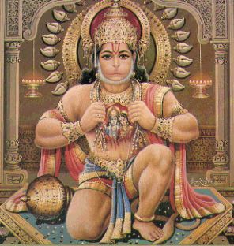

Bill Robinson

