Quartet
for a New Beginning

for Violin, Clarinet,
Violoncello, and Piano

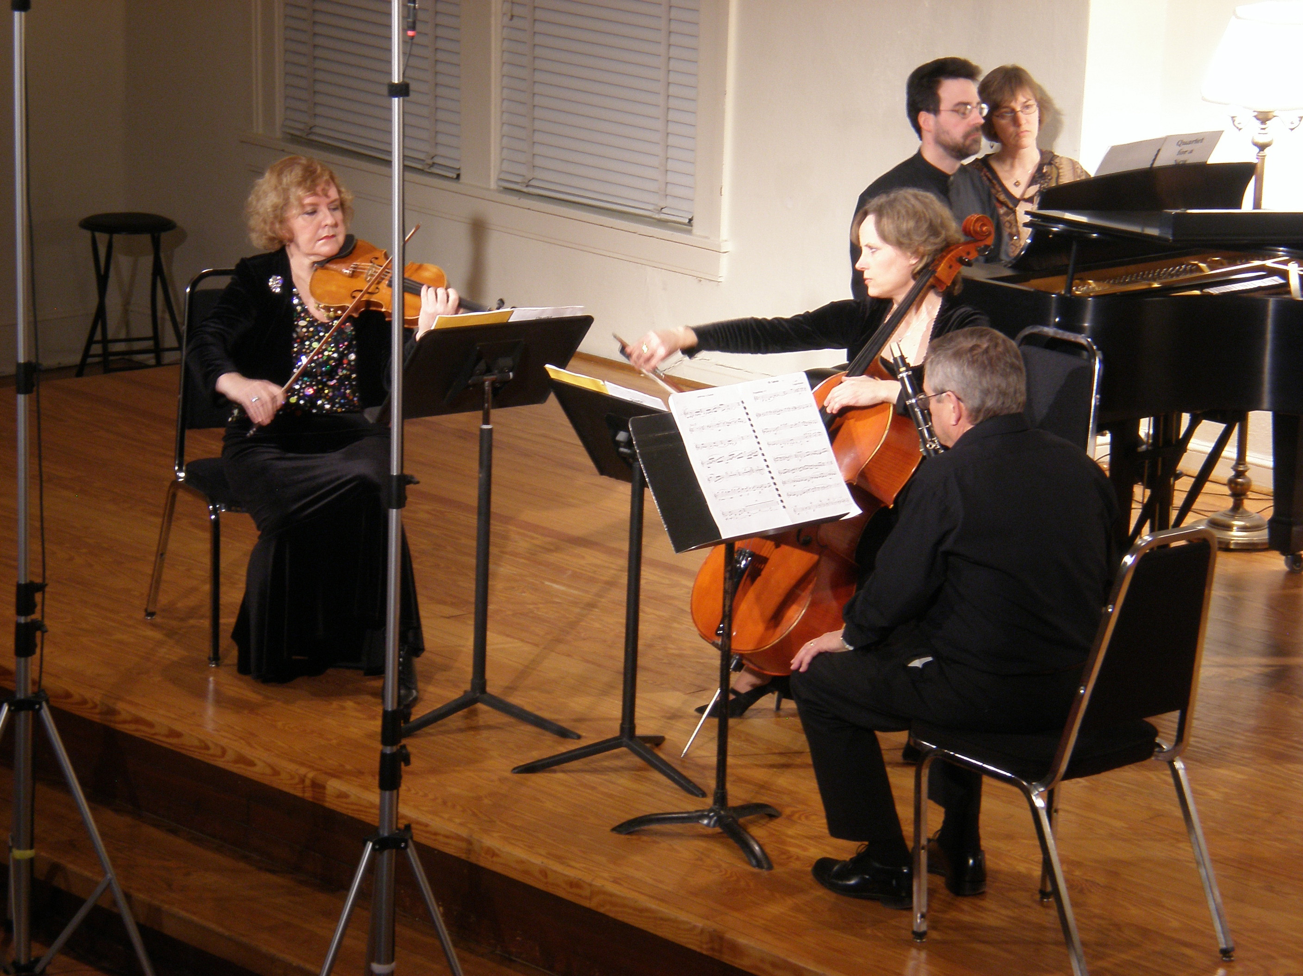

premier performance by Aurora Musicalis, February 10, 2010

Bill Robinson

