**Cello Concerto**

**Chamber Edition**

**for Cello and Two Pianos**

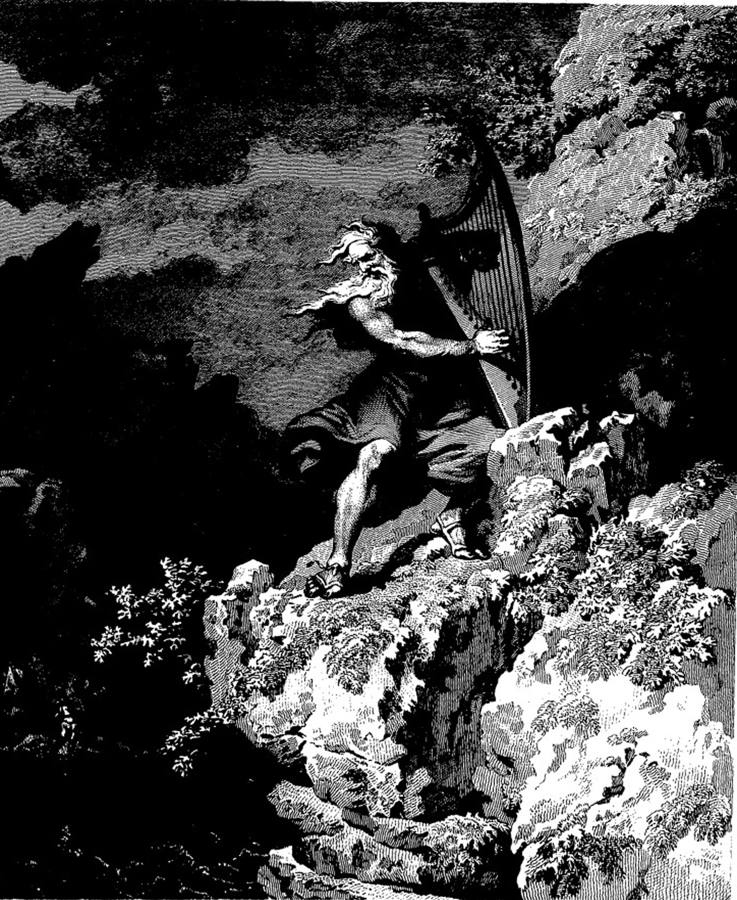

**Bill Robinson**