**Cello Concerto**

**Solo Cello**

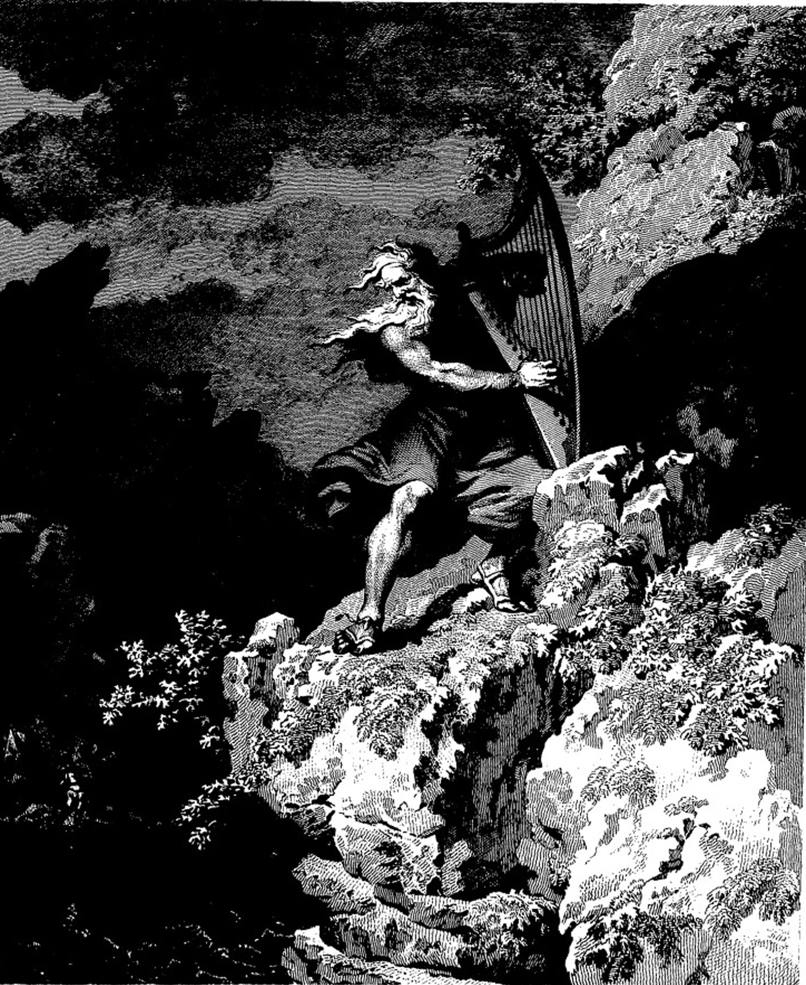

**Bill Robinson**