**Cello Concerto**

**Flute 2**

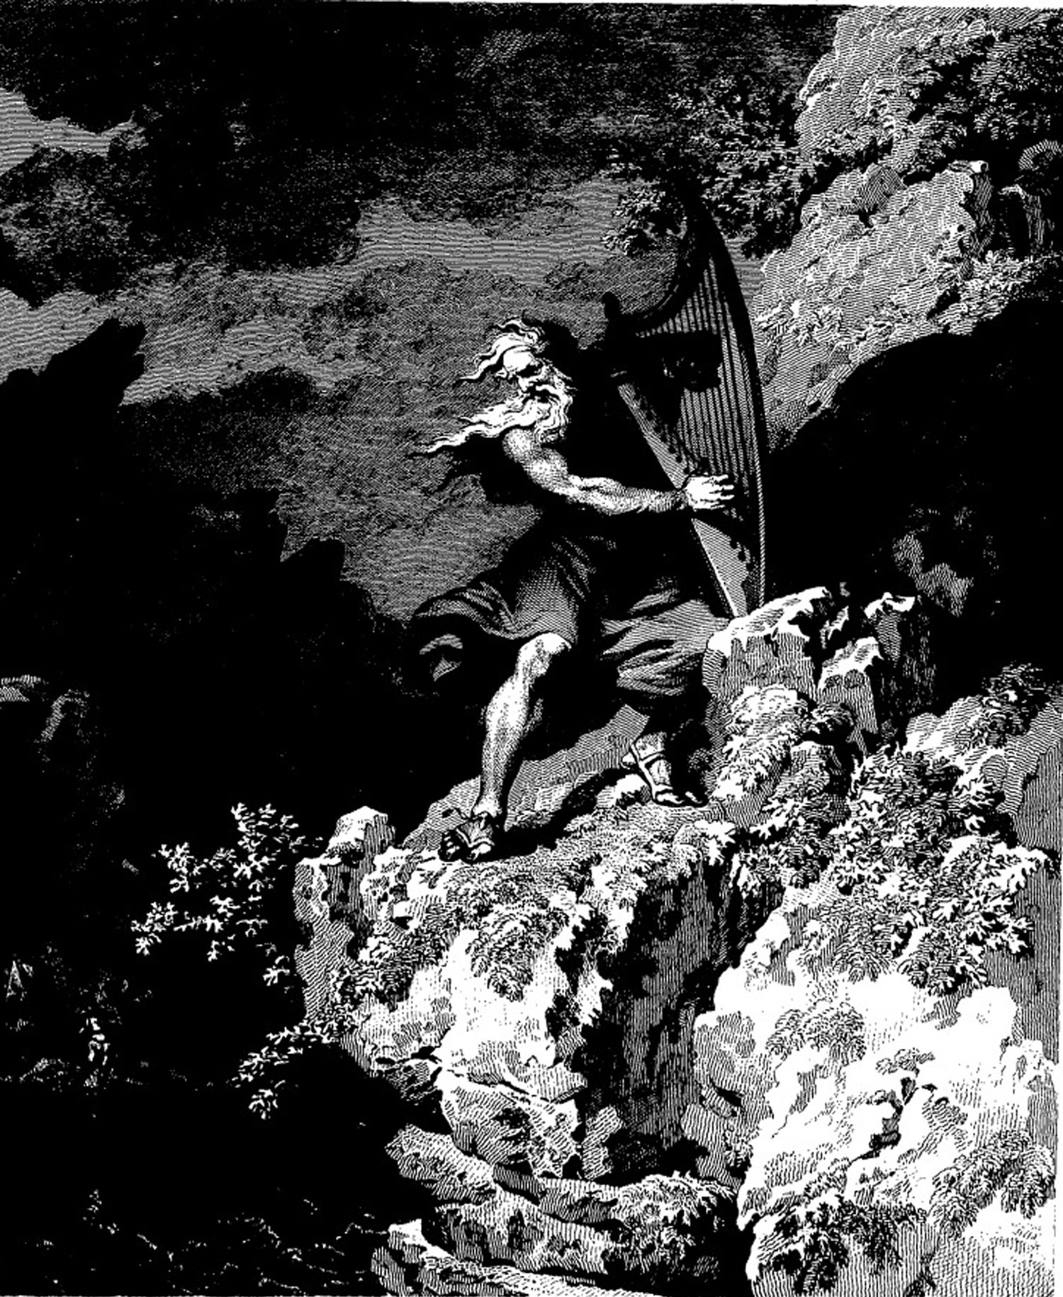

**Bill Robinson**