**Cello Concerto**

**Clarinet 2**

**in B flat**

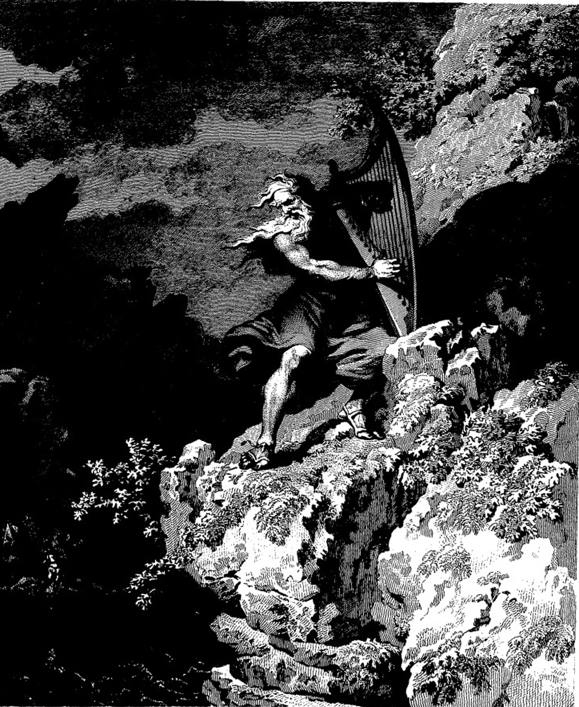

**Bill Robinson**