**Cello Concerto**

**Bassoon 1**

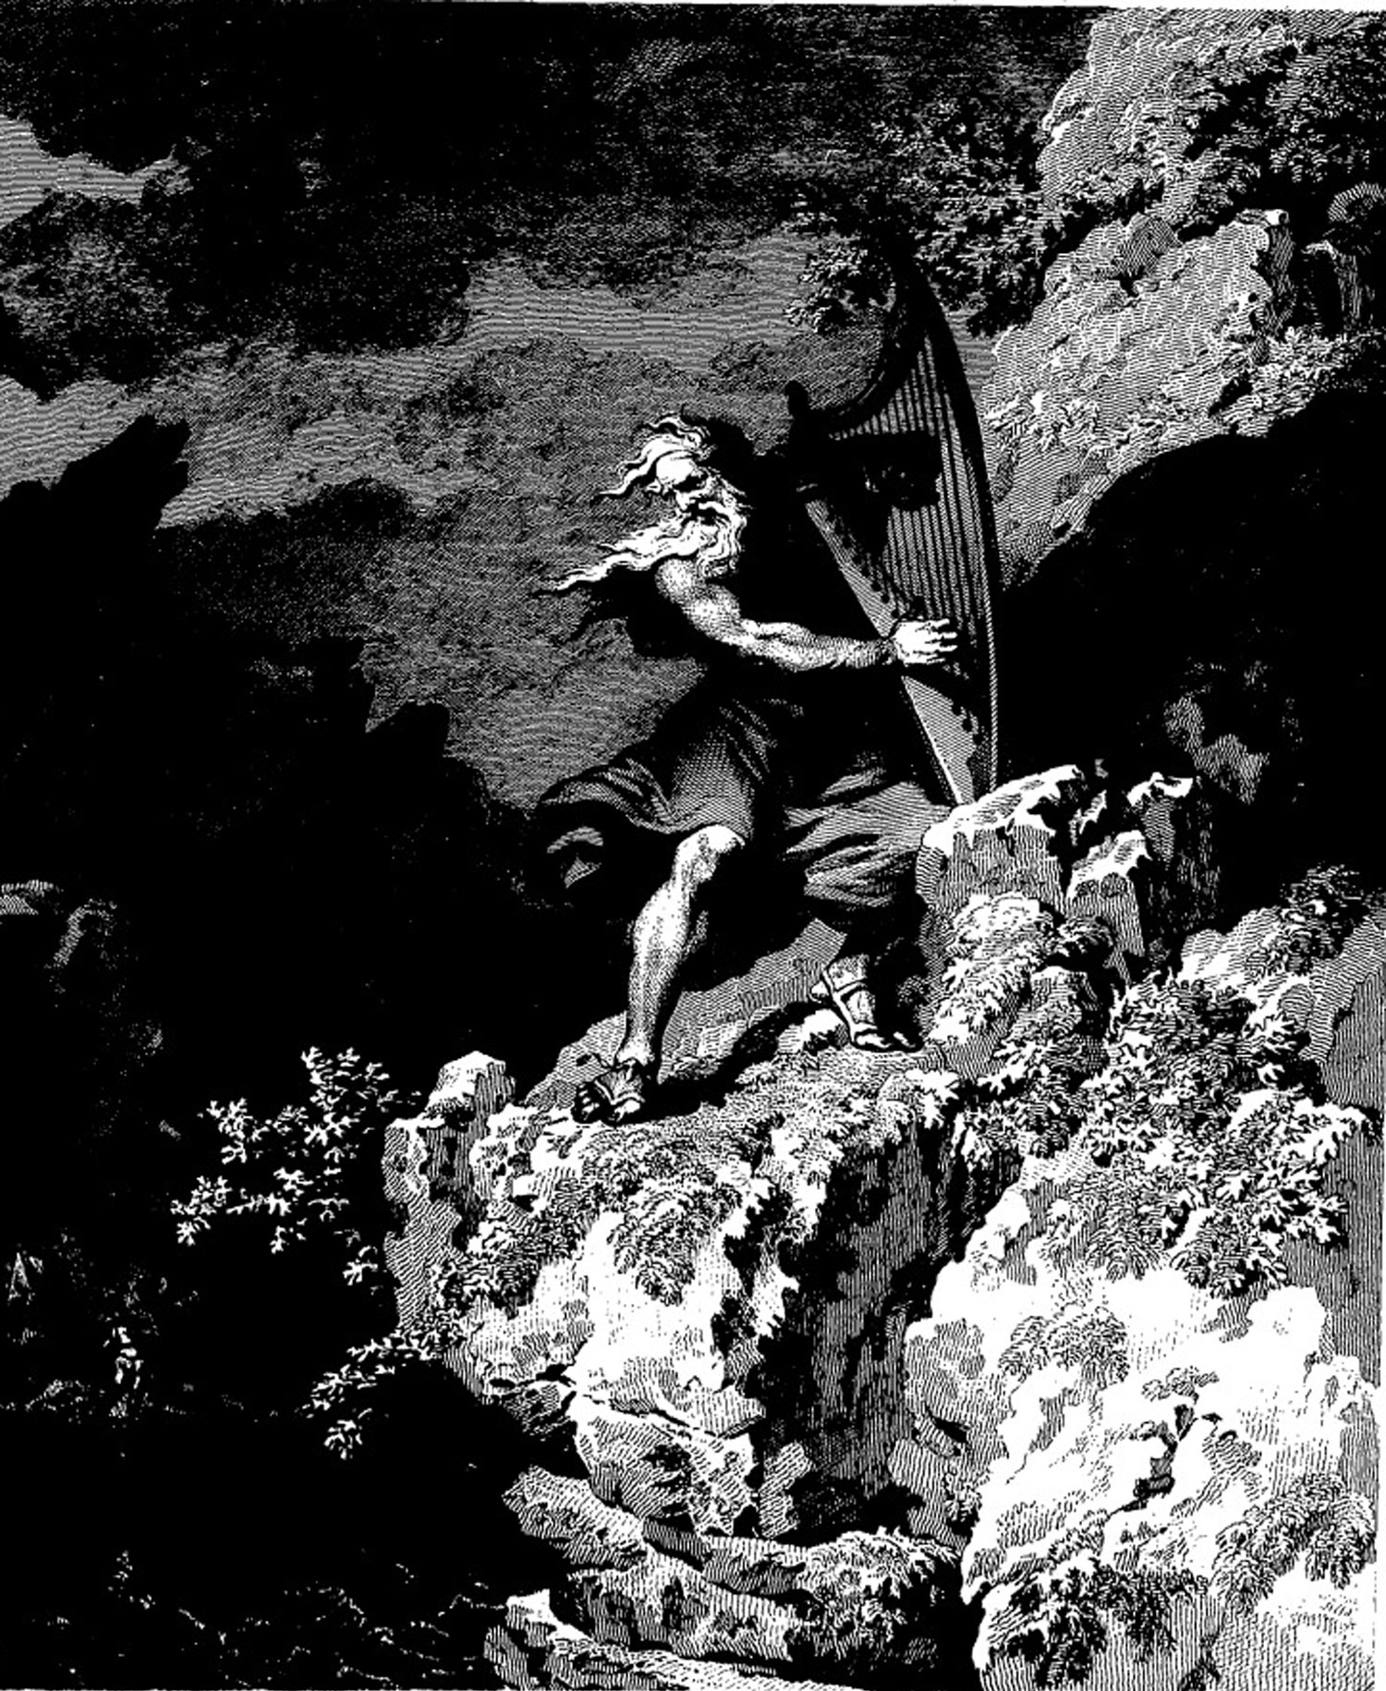

**Bill Robinson**