**Cello Concerto**

**Bassoon 2**

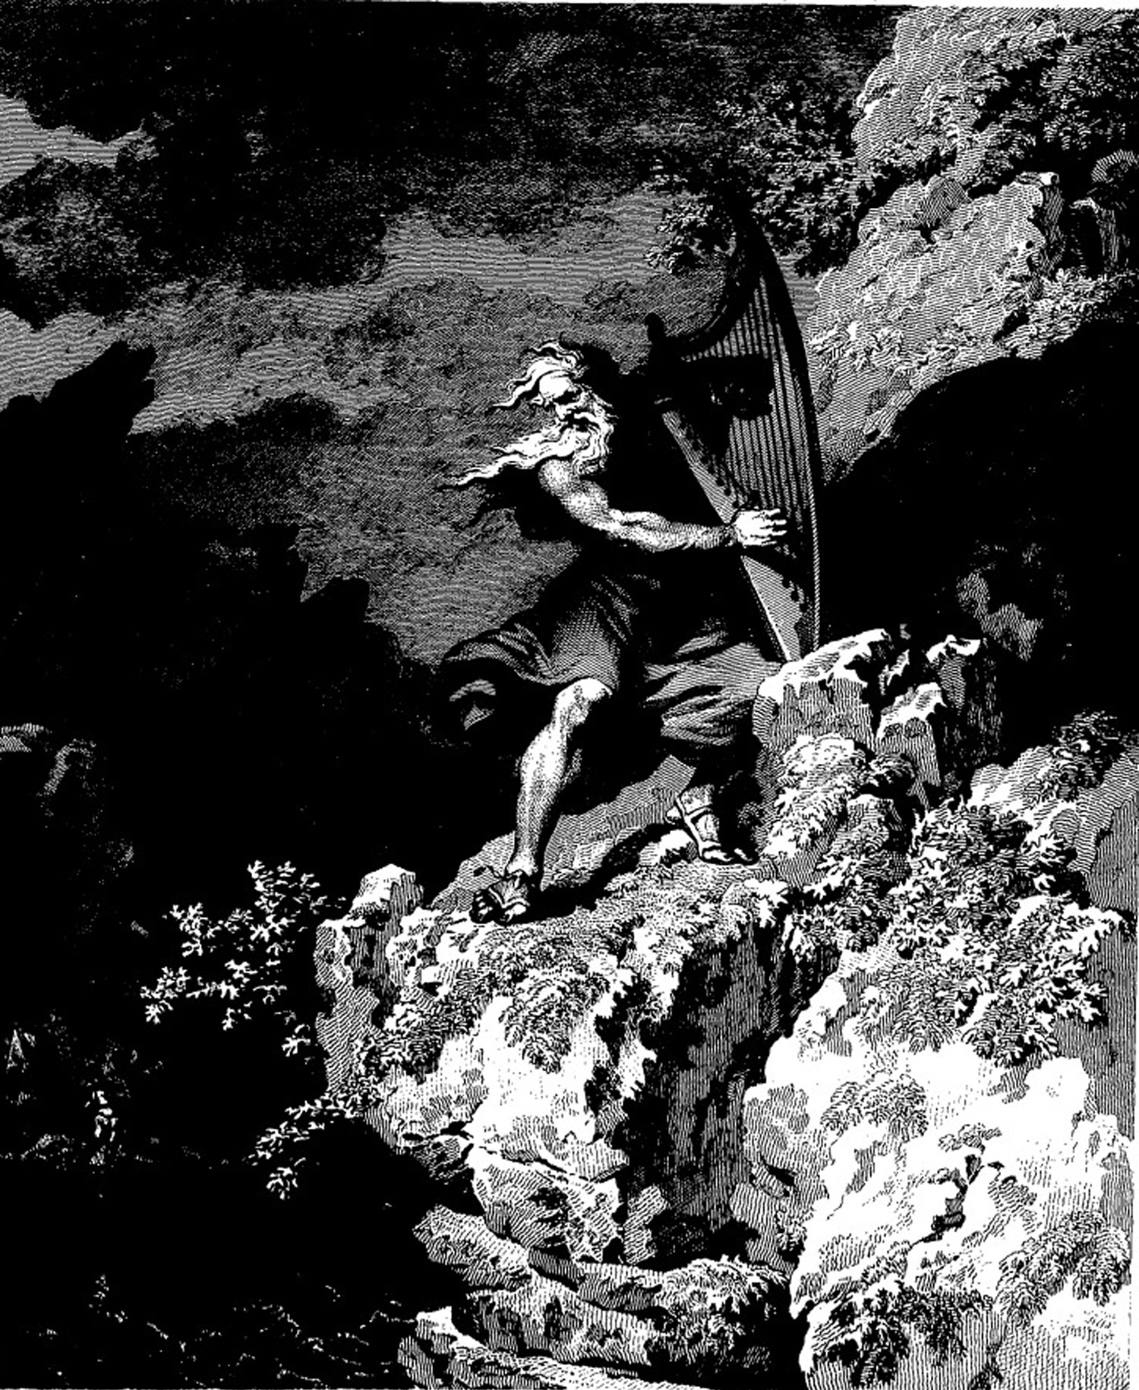

**Bill Robinson**