**Cello Concerto**

**Trumpet 1**

**in B flat**

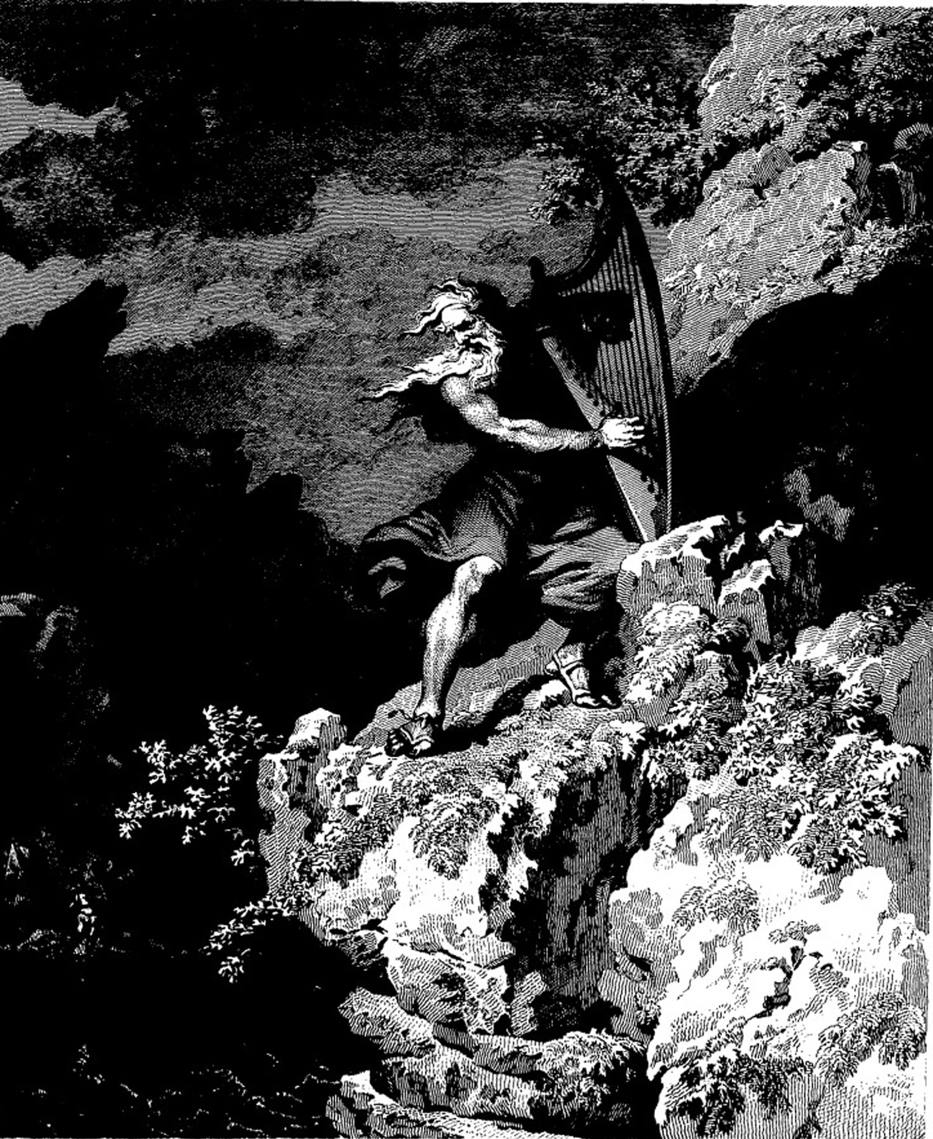

**Bill Robinson**