**Cello Concerto**

**Trumpet 2**

**in B flat**

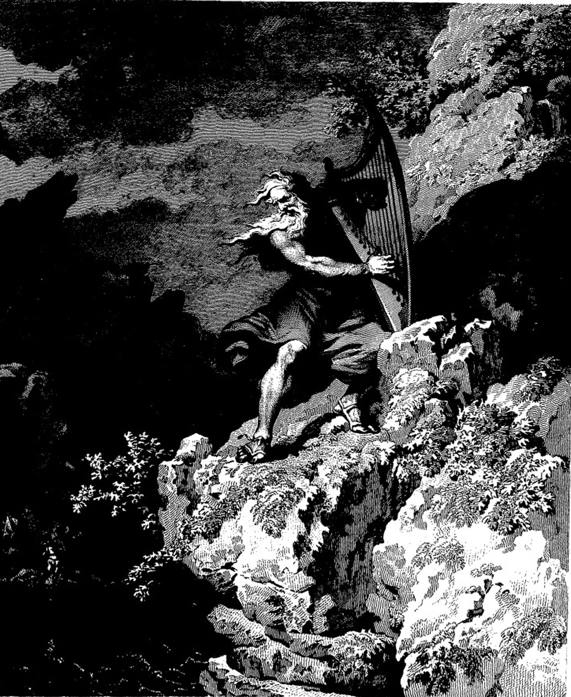

**Bill Robinson**