**Cello Concerto**

**Timpani**

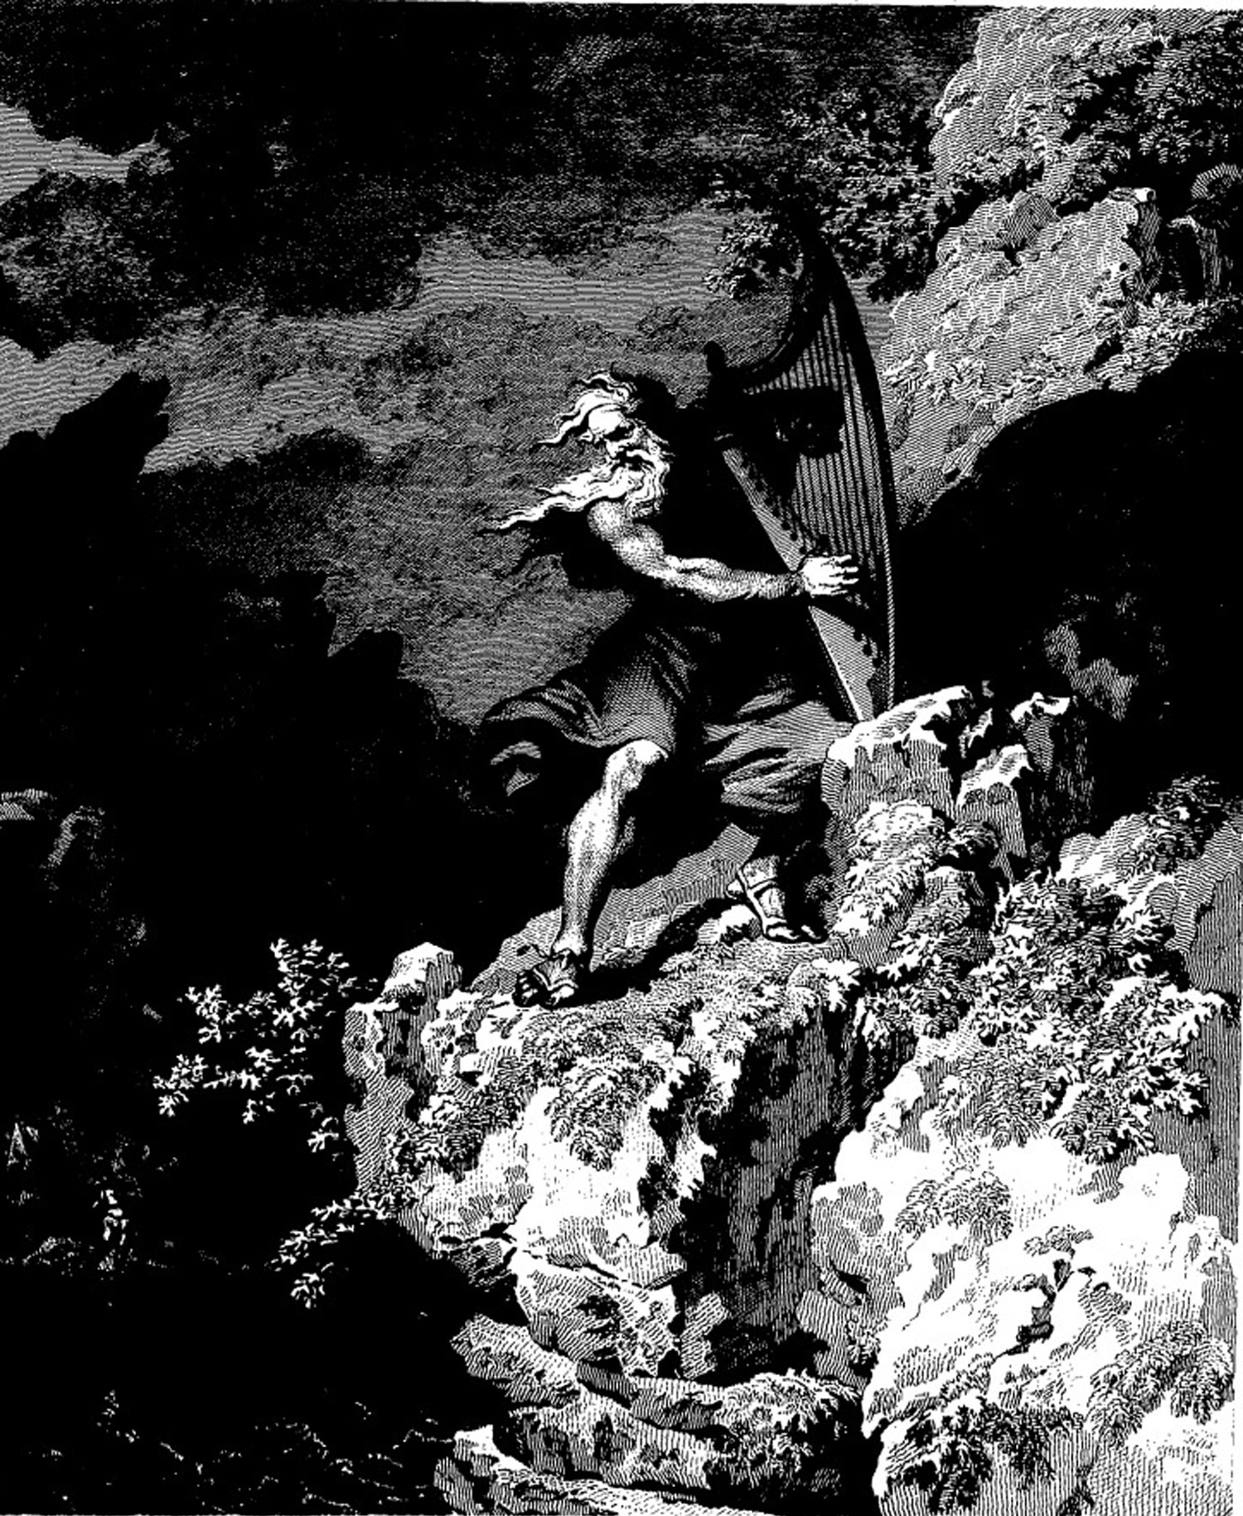

**Bill Robinson**