**Cello Concerto**

**Orchestral Cello**

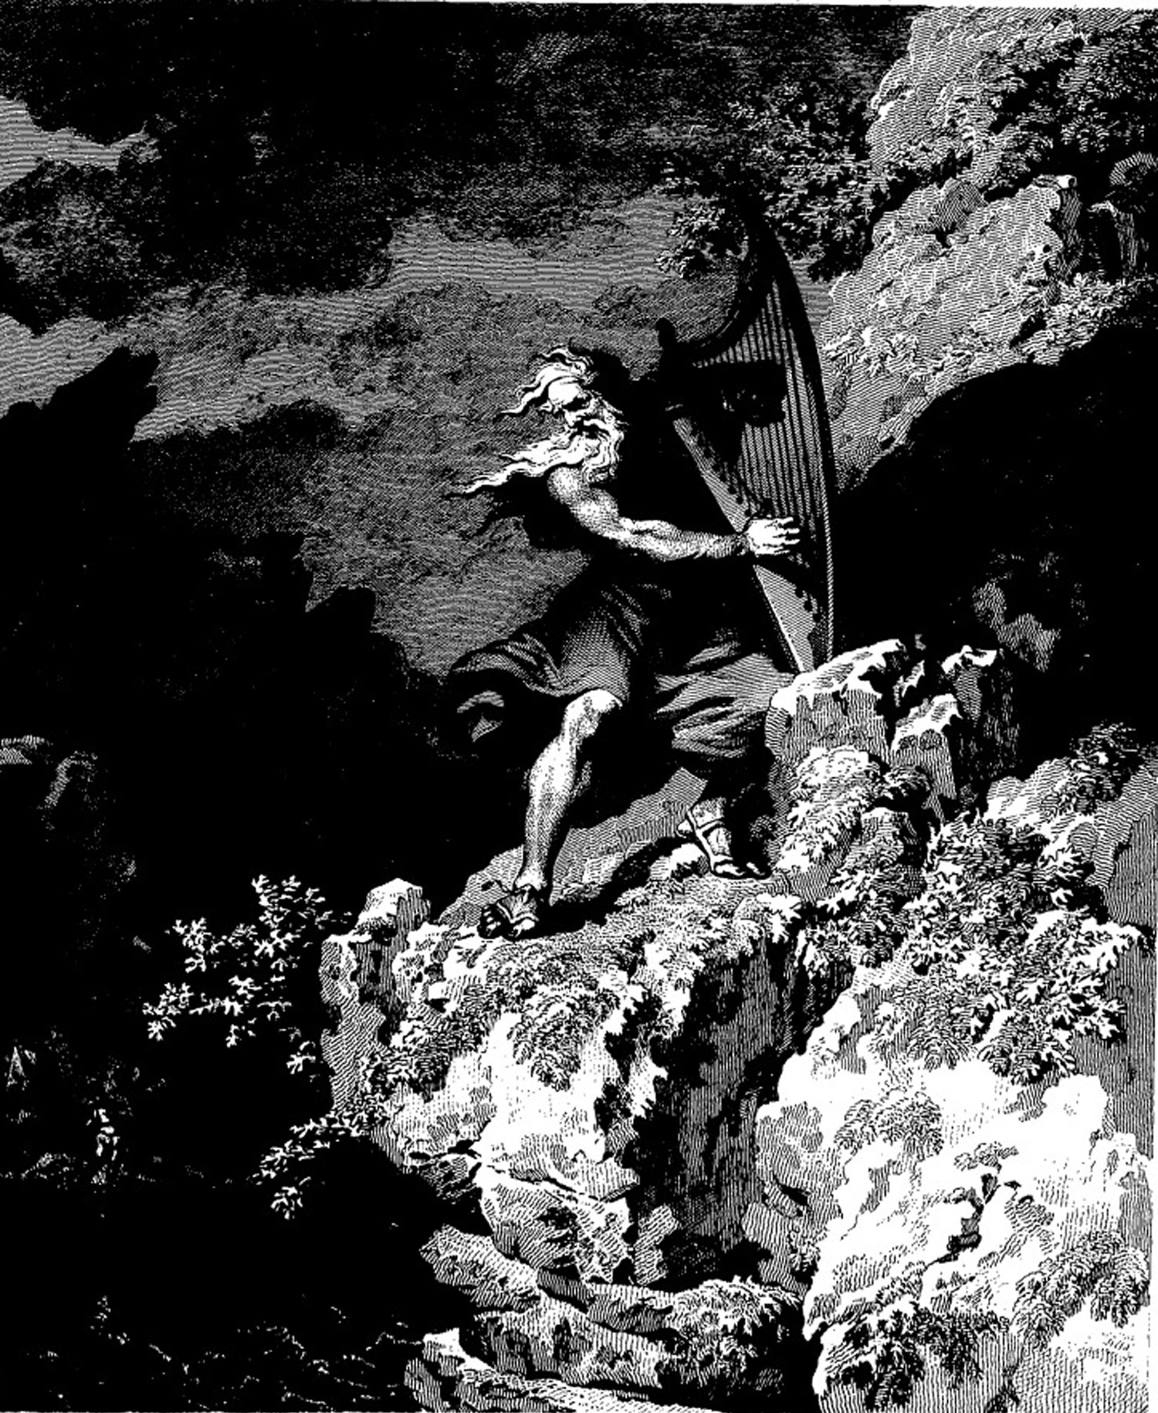

**Bill Robinson**