**Cello Concerto**

**Double Bass**

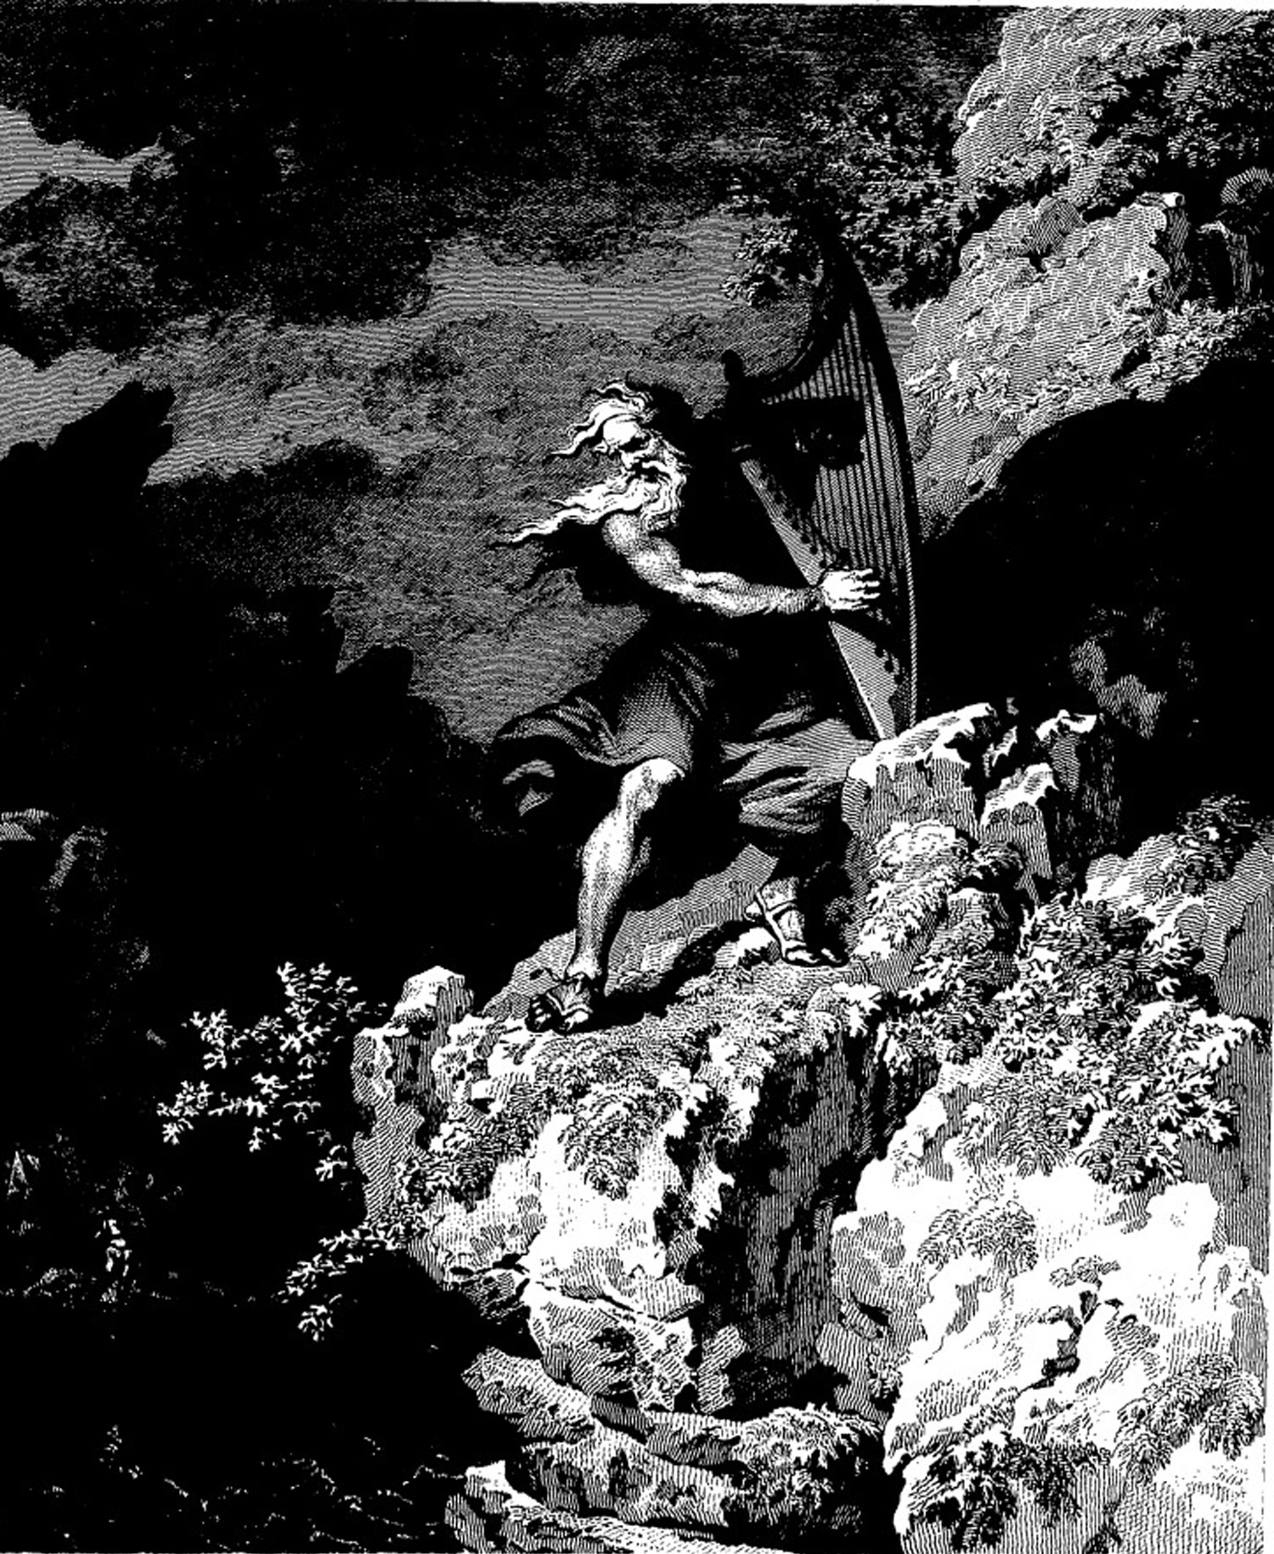

**Bill Robinson**