Chamber Concerto

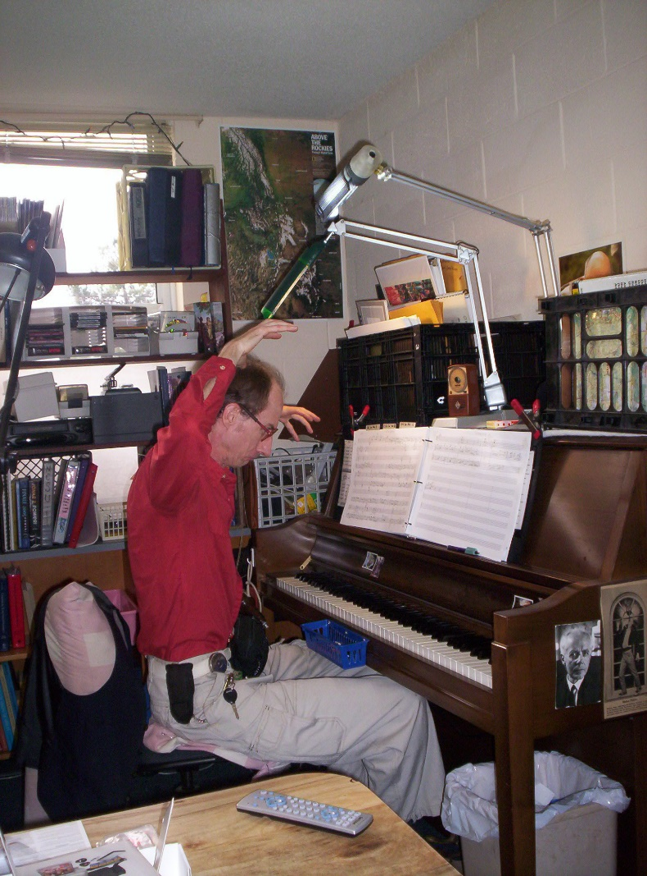

for Piano and

String Quartet

Bill Robinson