Chamber Concerto
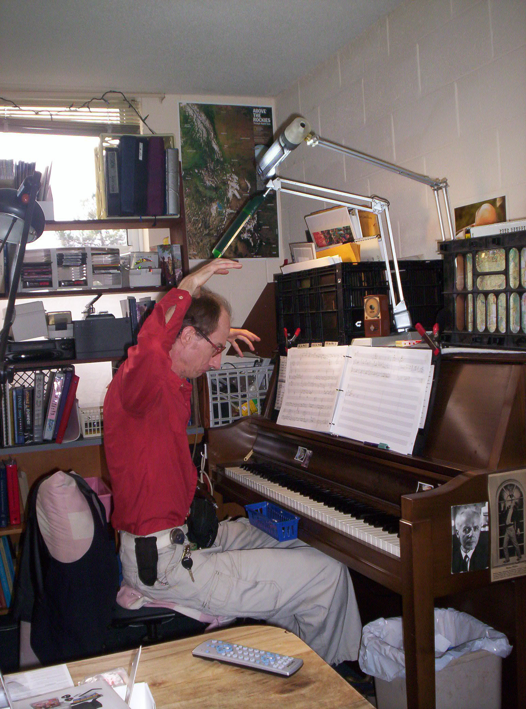

for Piano, String Orchestra,
and Timpani

Bill Robinson

