Chamber Concerto
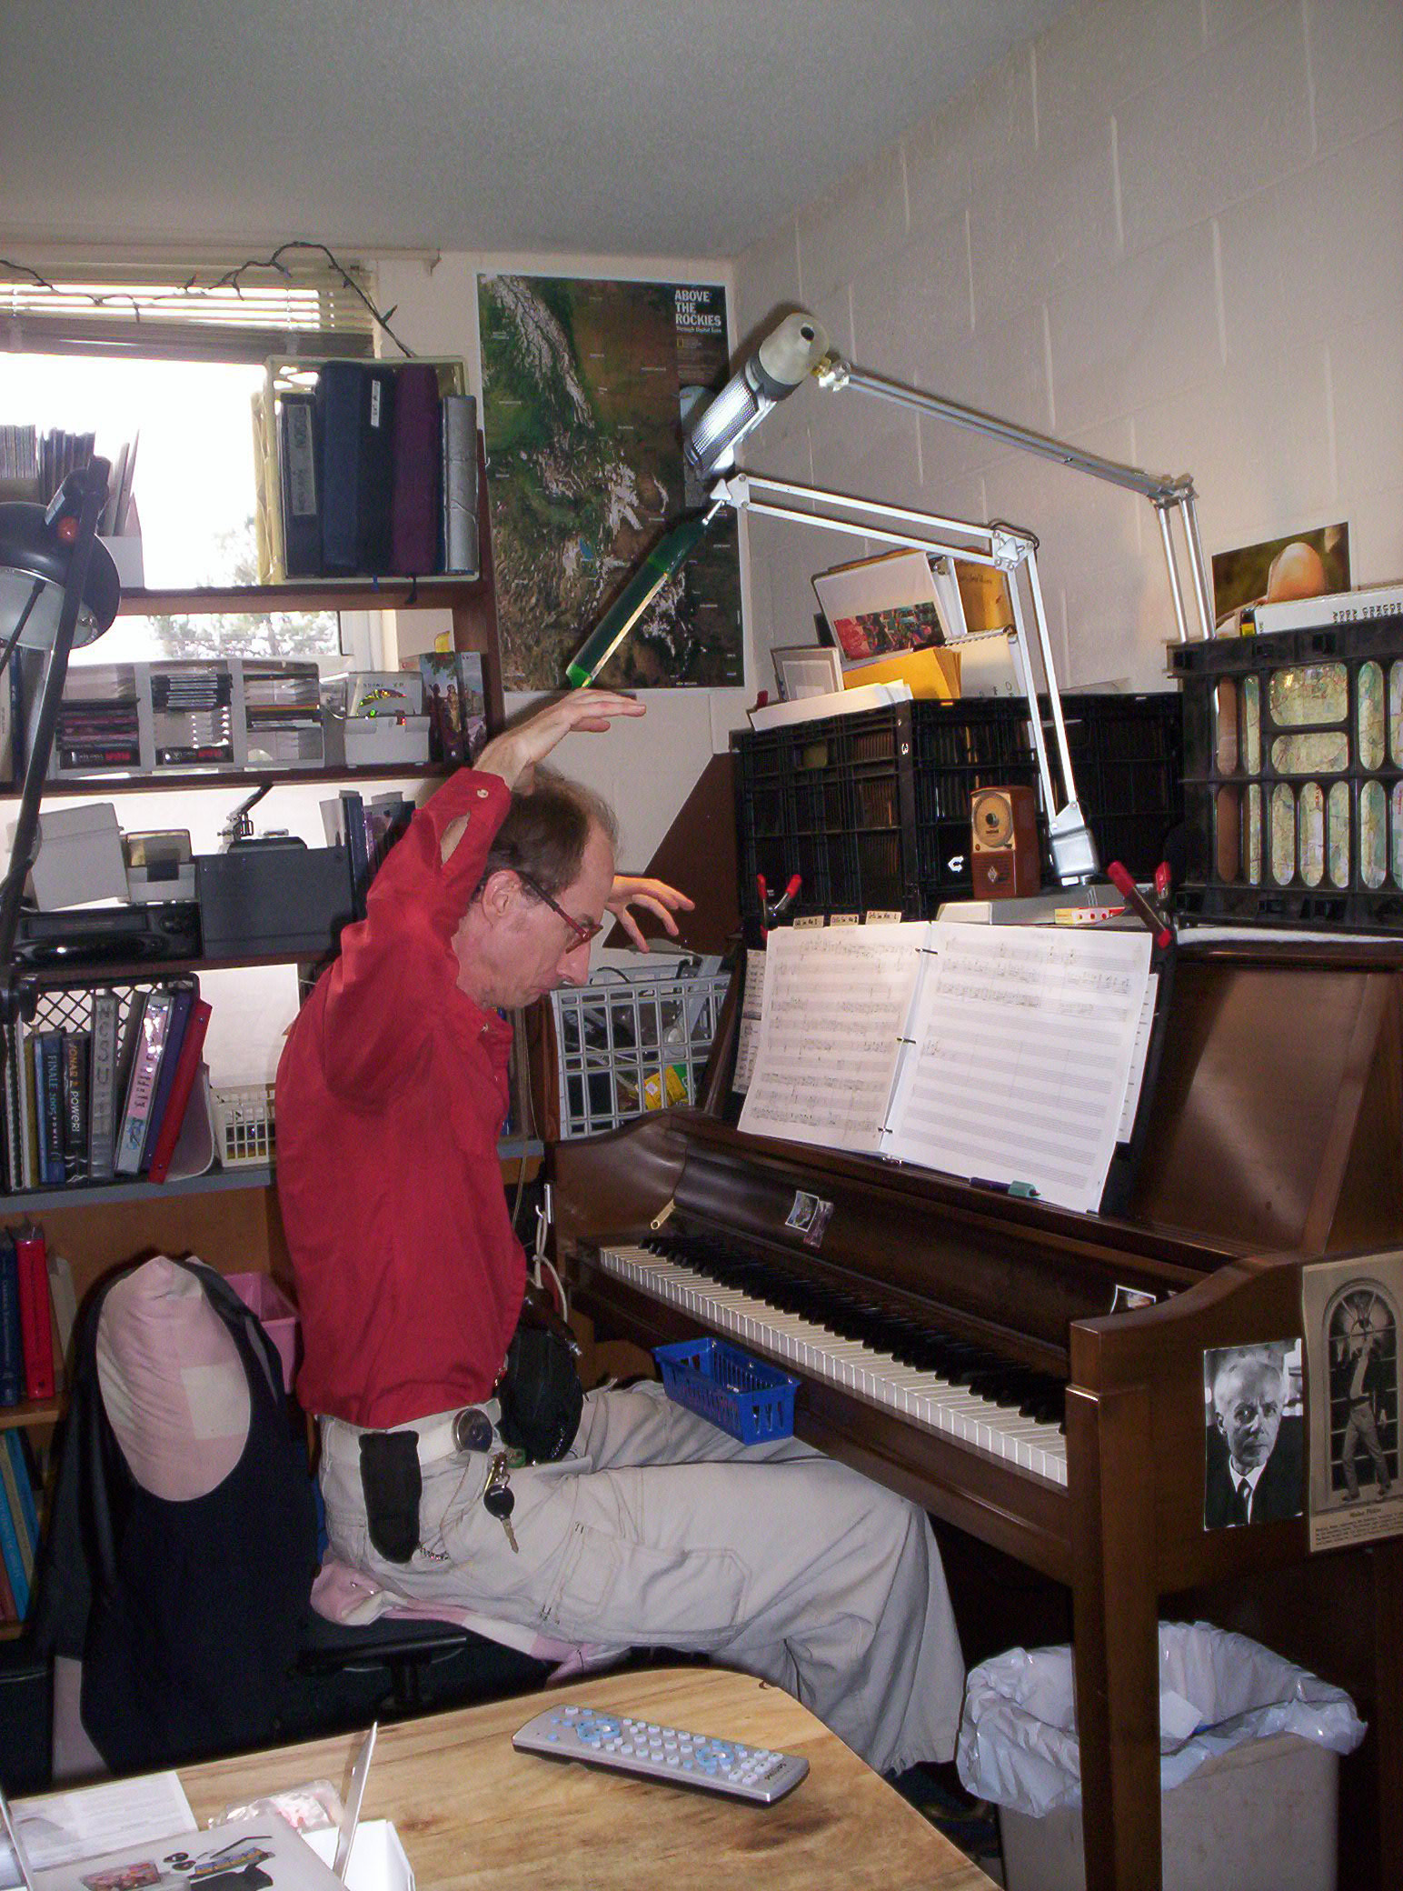
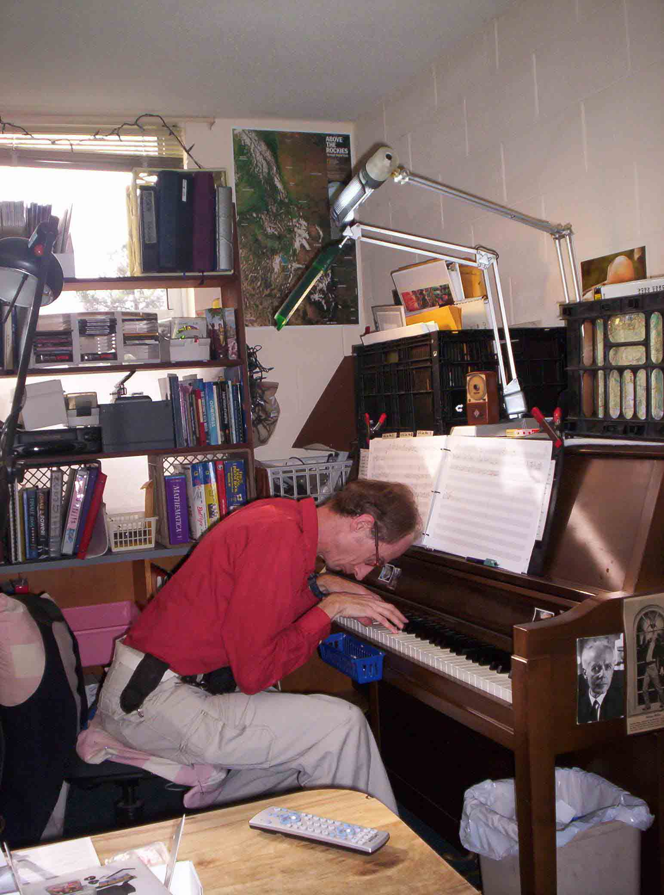
for Piano and
Small Orchestra

Bill Robinson

