Diatonic Phrygian Tetrachord

*for Violin and Chamber Orchestra*

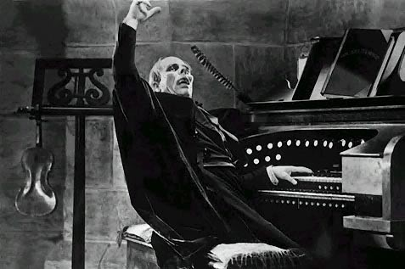

Bill Robinson