Diatonic Phrygian Tetrachord

*for Violin*

*and Chamber Orchestra*

**Solo Violin**

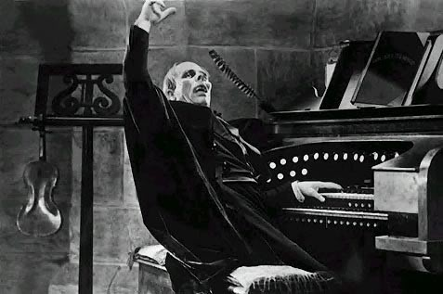

Bill Robinson