Diatonic Phrygian Tetrachord

*for Violin*

*and Chamber Orchestra*

**Violin I**

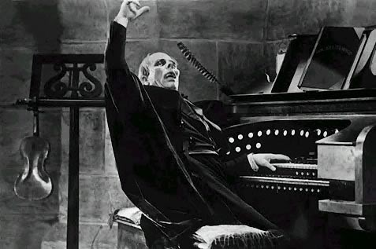

Bill Robinson