Mozart’s

Twelve-Tone Row

*for Orchestra*

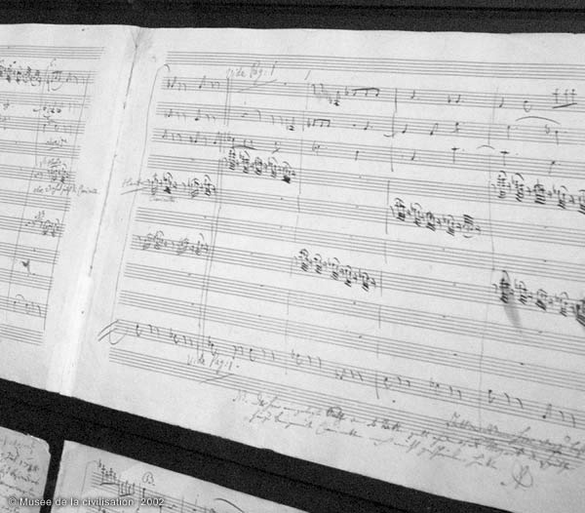

Bill Robinson