Violin Concerto No. 2

for Violin

and Orchestra

­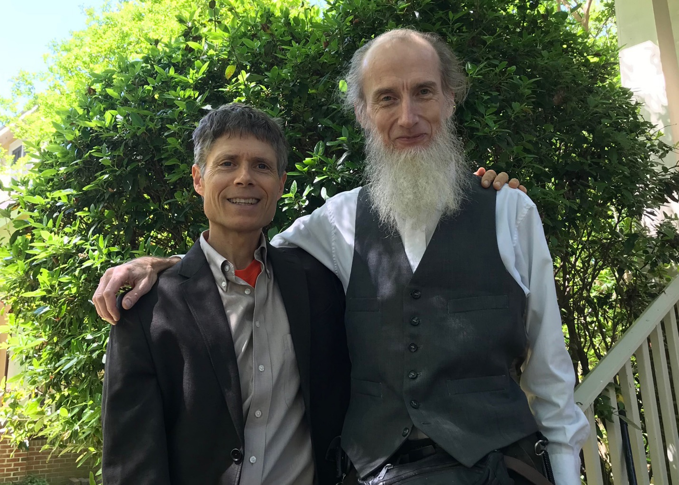

Bill Robinson