­ Violin Concerto No. 2

Chamber version for Violin and Two Pianos

­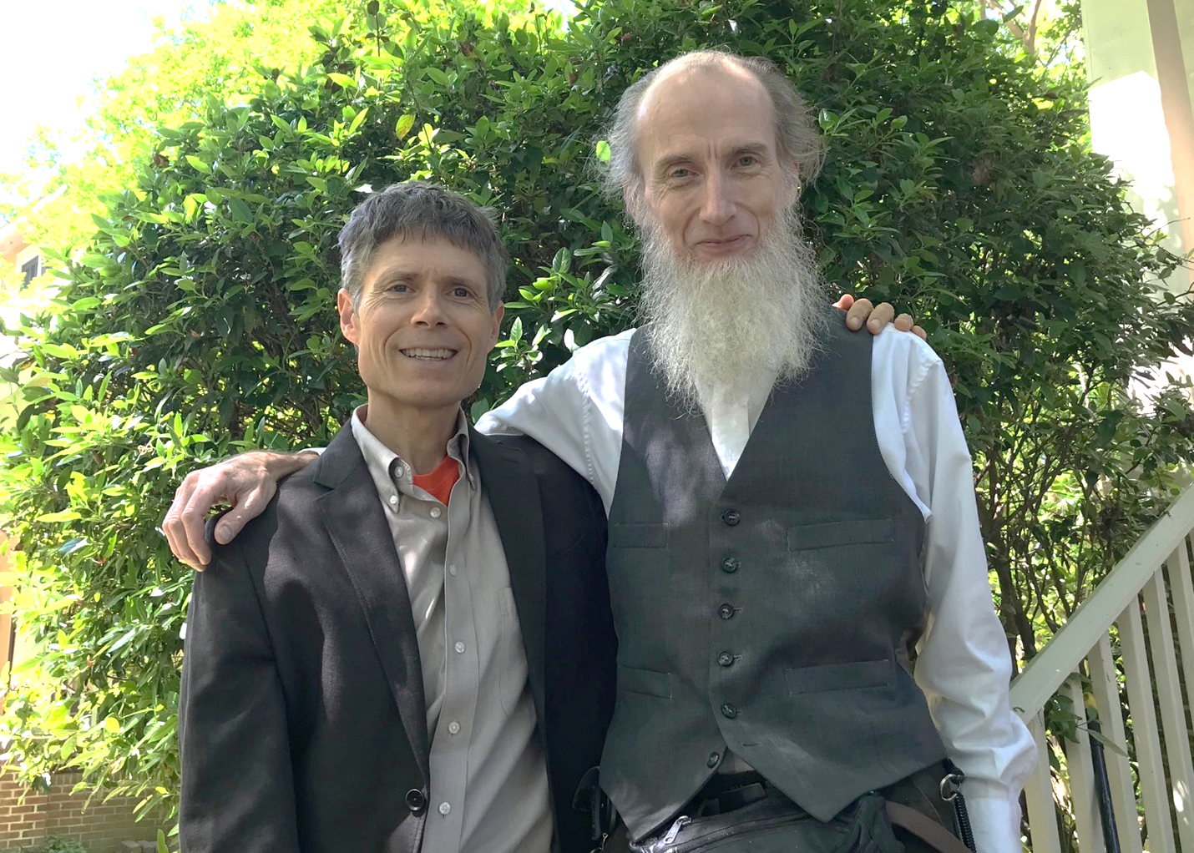

Bill Robinson