Waltz

For Our Time

*for Orchestra*

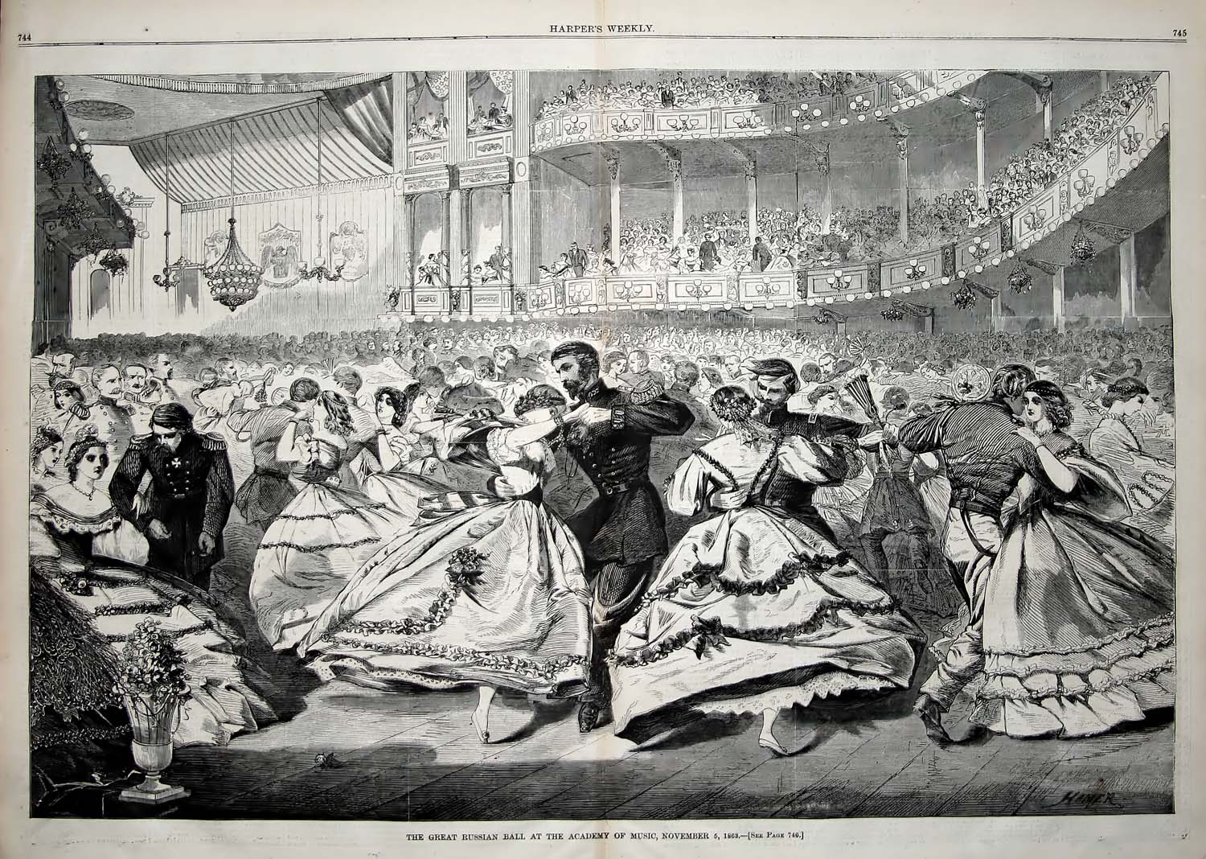

Bill Robinson