Waltz For Our Time

*­­*Flute 1

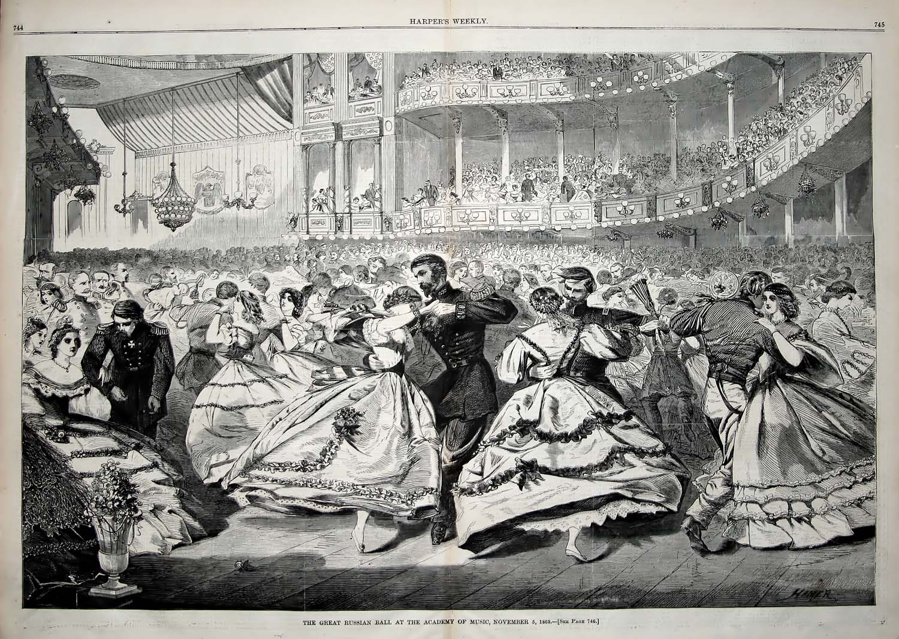

Bill Robinson