Waltz For Our Time

*­­*Flute 2/Piccolo

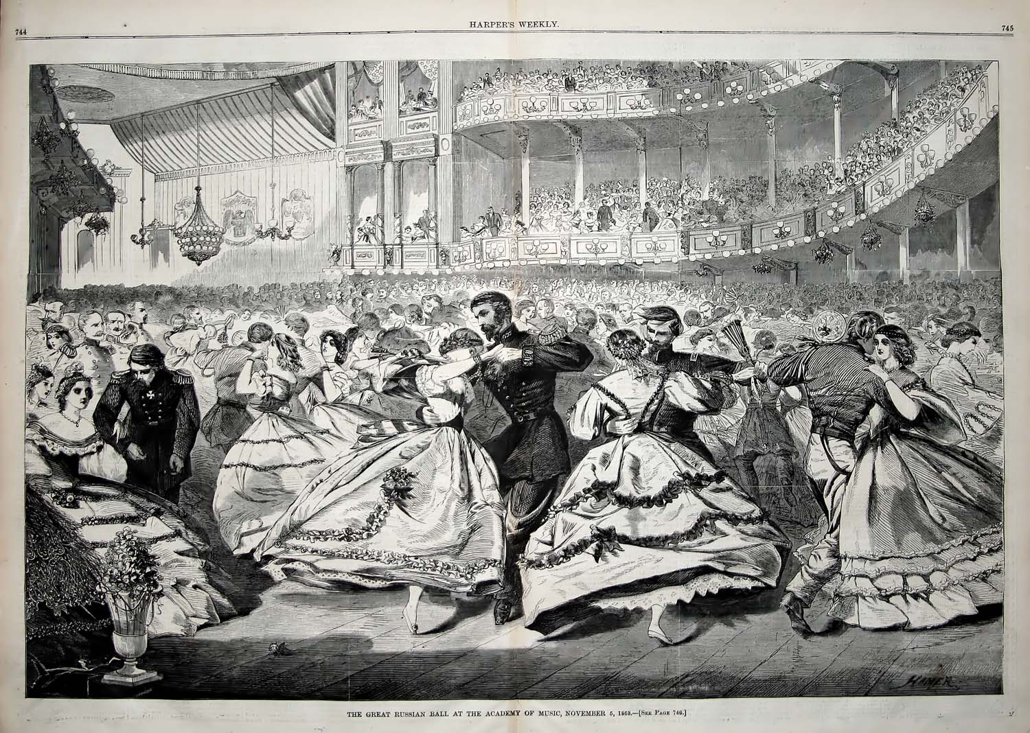

Bill Robinson