Waltz For Our Time

*­­*Oboe 1

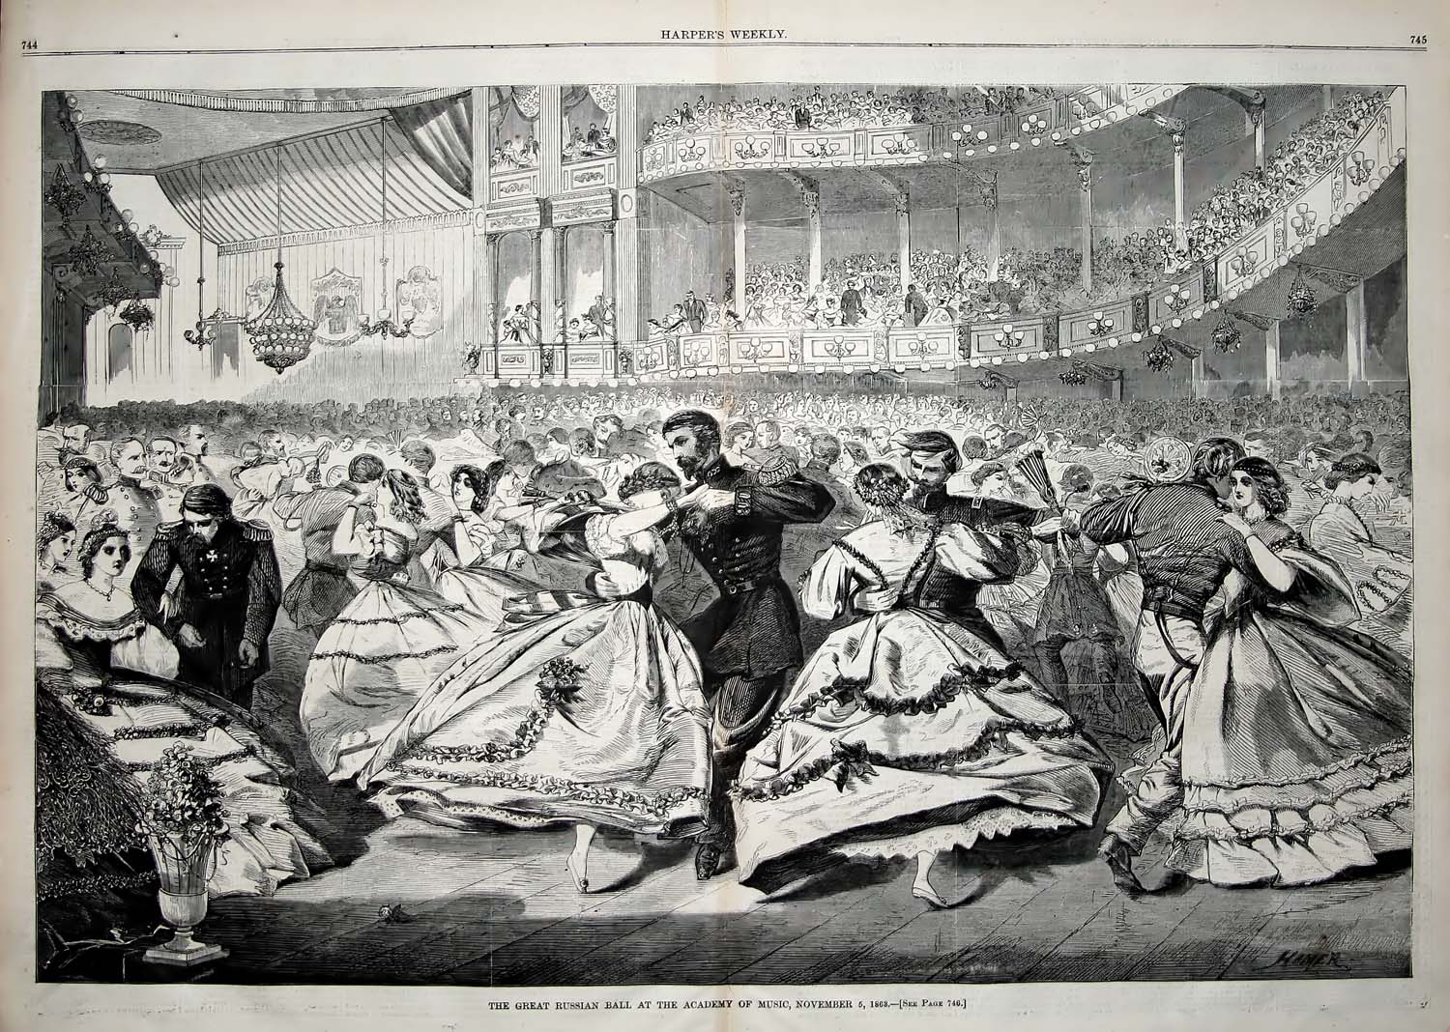

Bill Robinson