Waltz For Our Time

*­­*Oboe 2

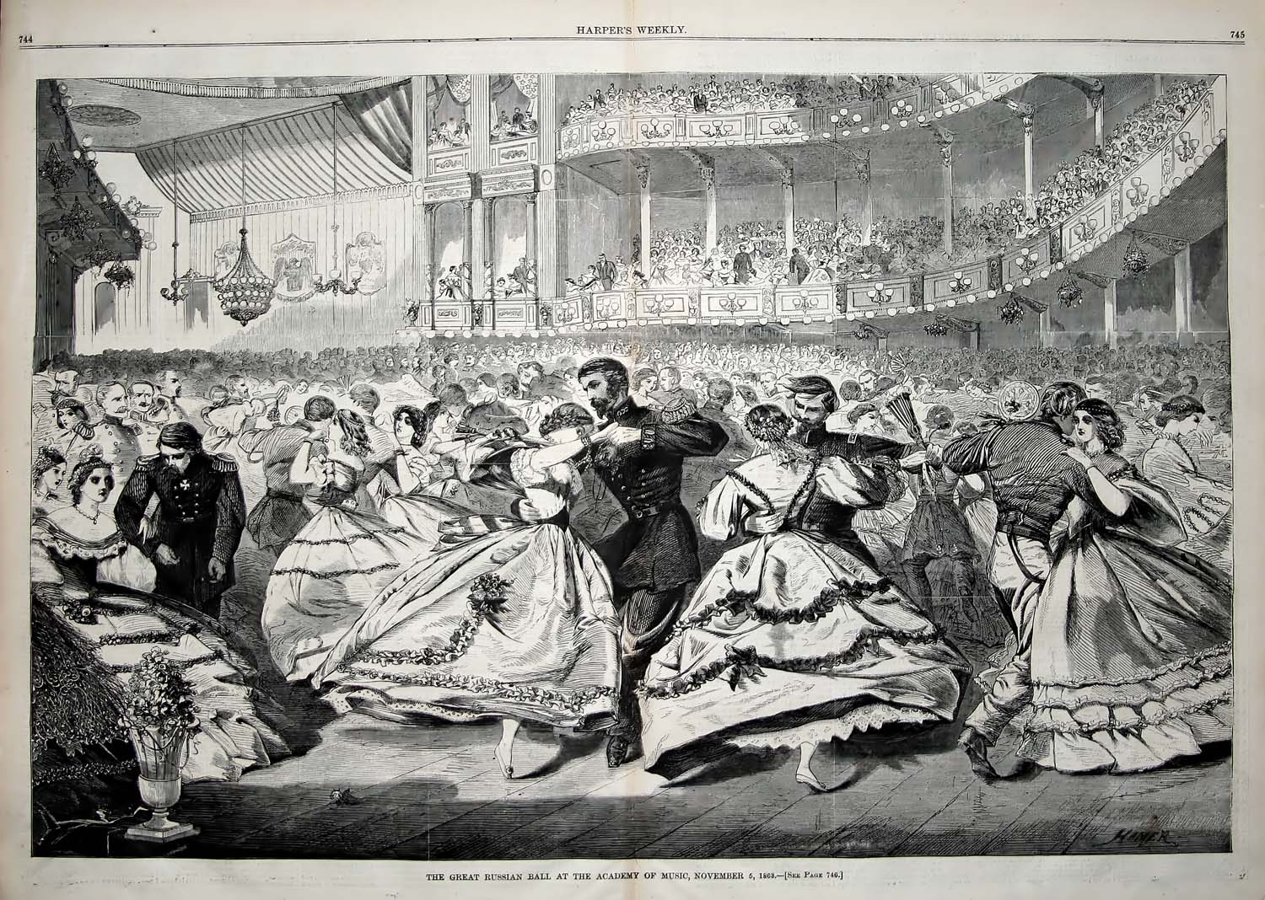

Bill Robinson