Waltz For Our Time

*­­*Clarinet 2 in Bb

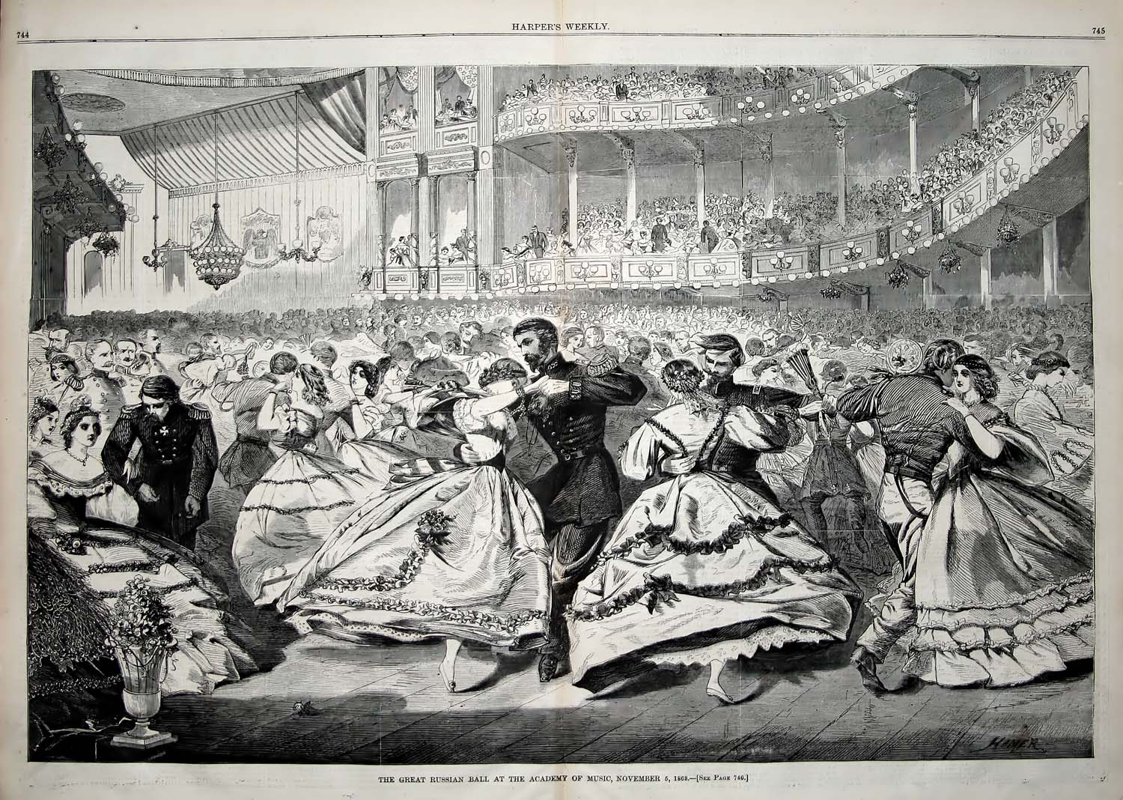

Bill Robinson