Waltz For Our Time

*­­*Bassoon 1

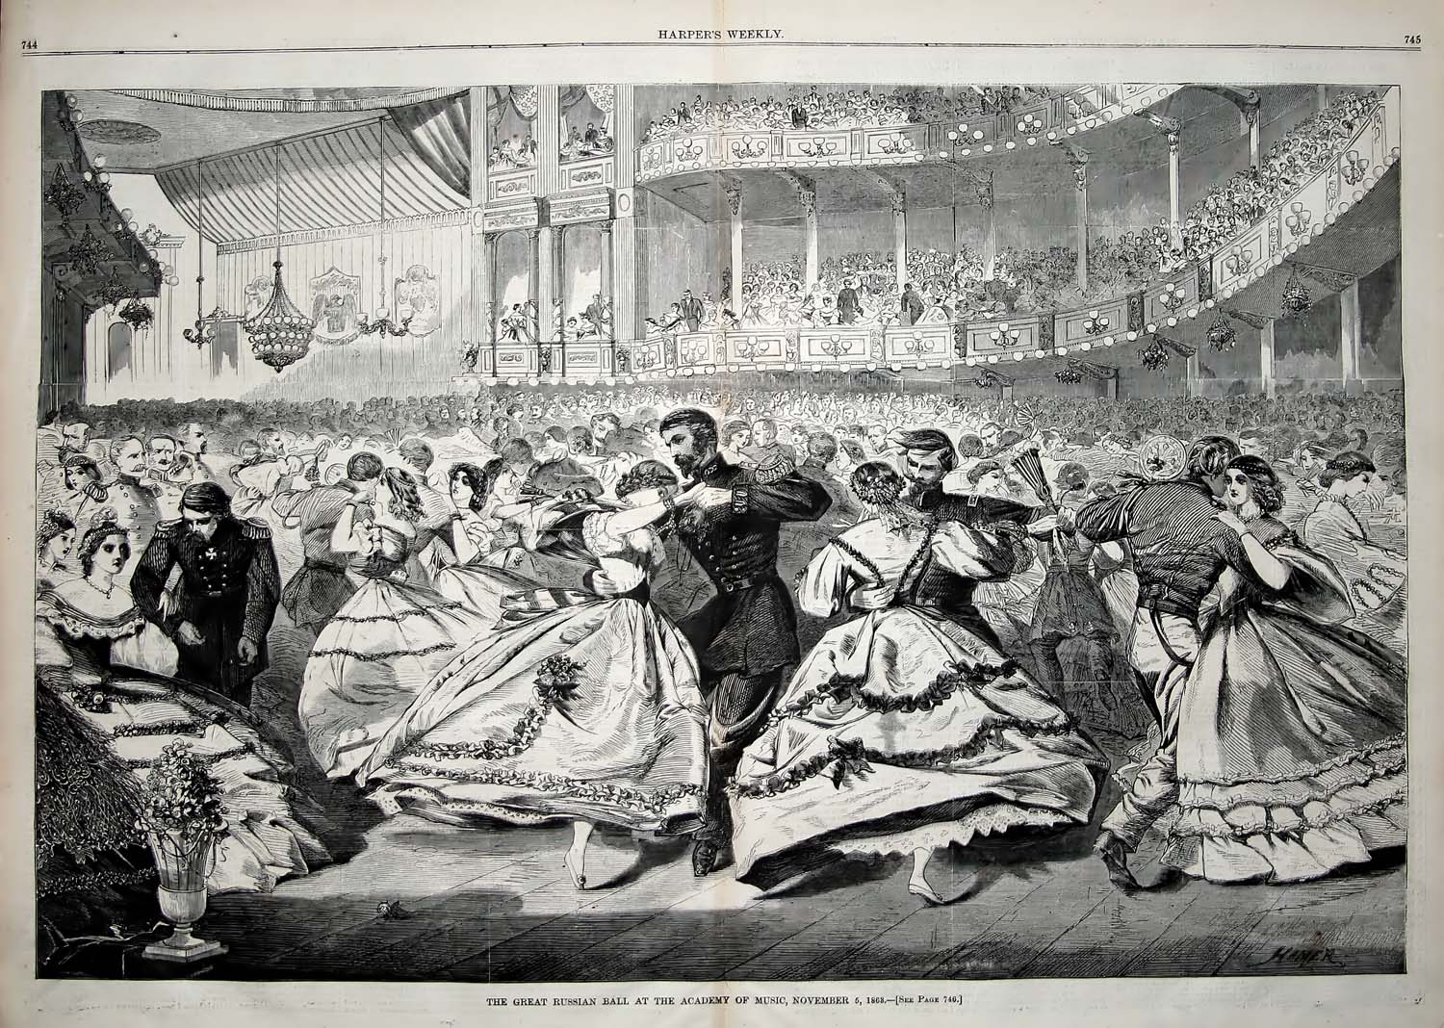

Bill Robinson