Waltz For Our Time

*­­*Bassoon 2

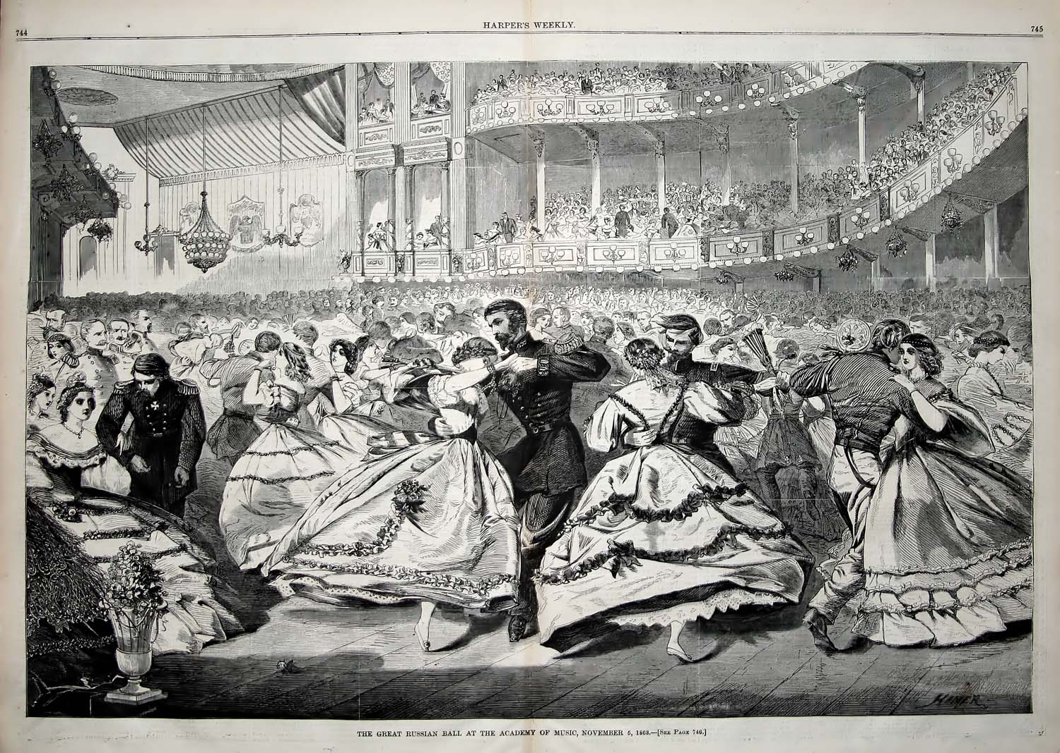

Bill Robinson