Waltz For Our Time

*­­*Trumpet 1 in Bb

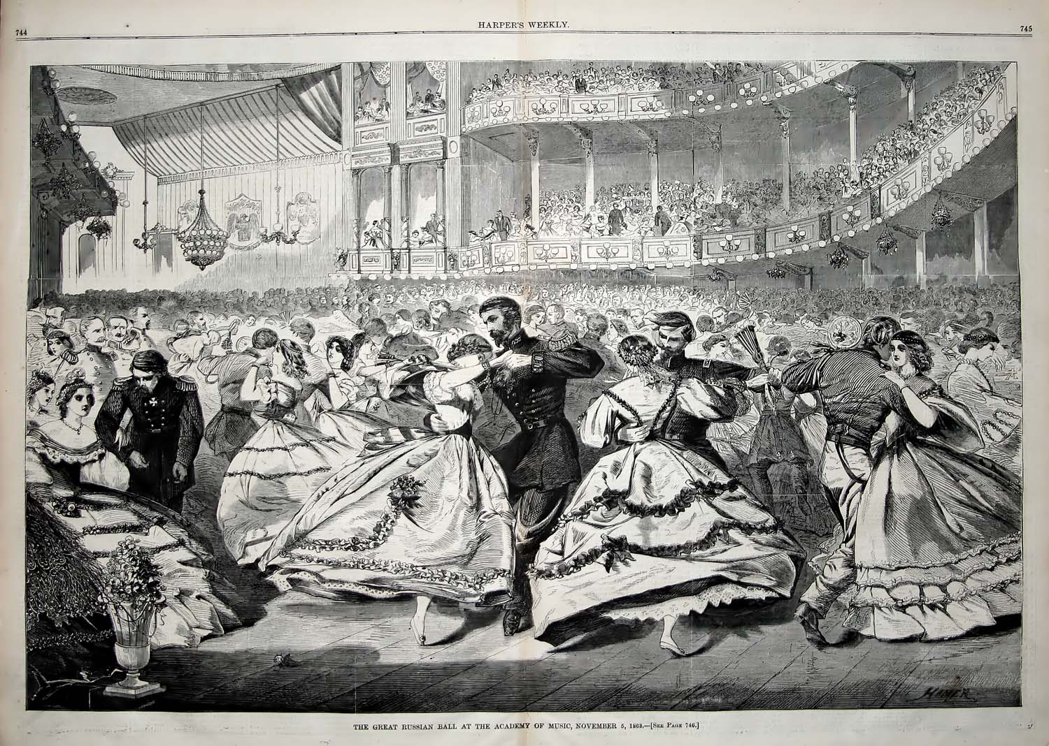

Bill Robinson