Waltz For Our Time

*­­*Trumpet 2 in Bb

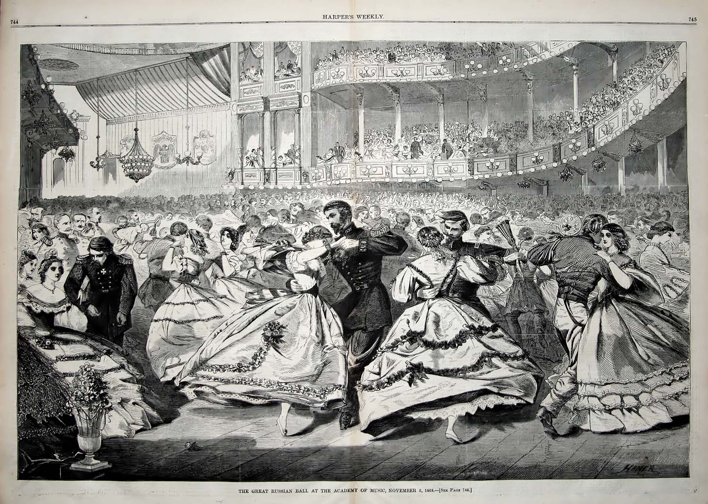

Bill Robinson