Waltz For Our Time

*­­*Bass Trombone

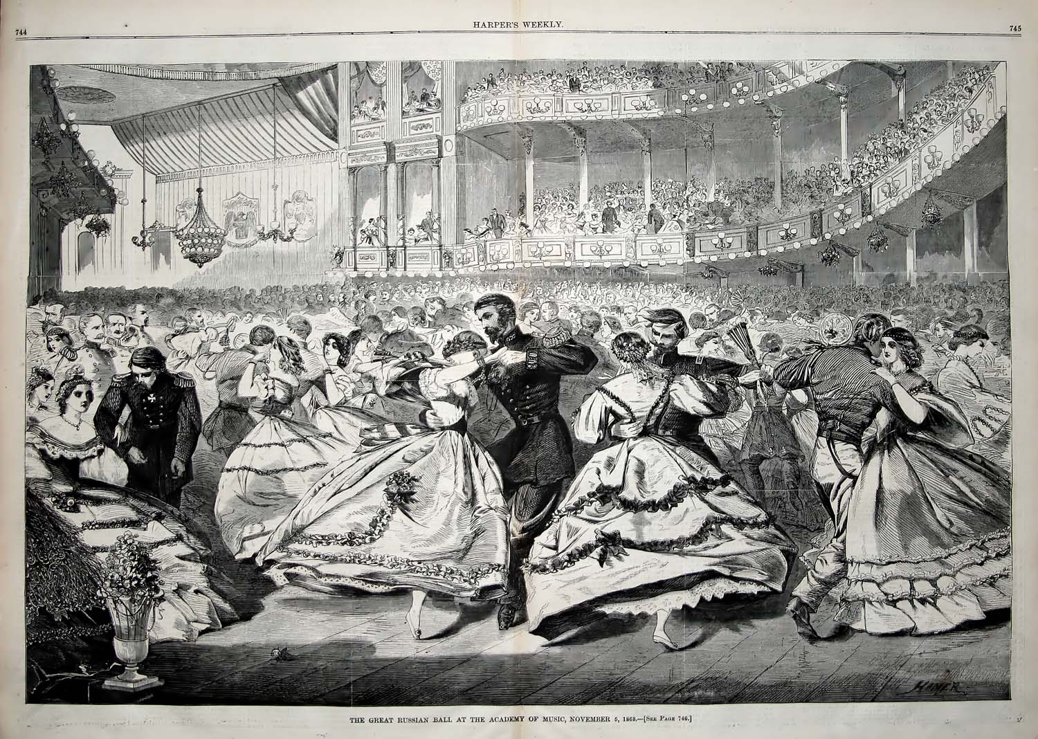

Bill Robinson