Waltz For Our Time

*­­*Tuba

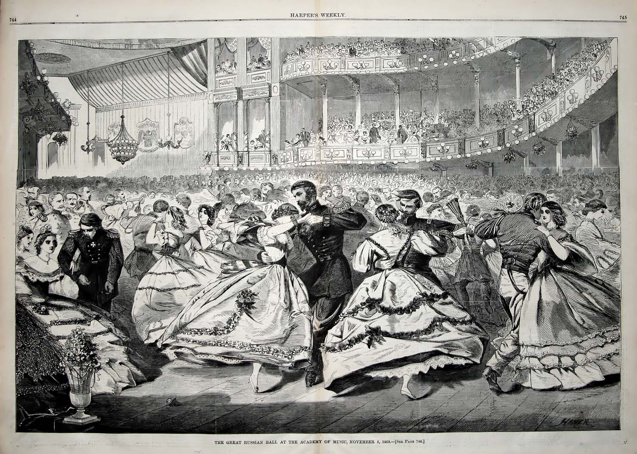

Bill Robinson