Waltz For Our Time

*­­*Timpani

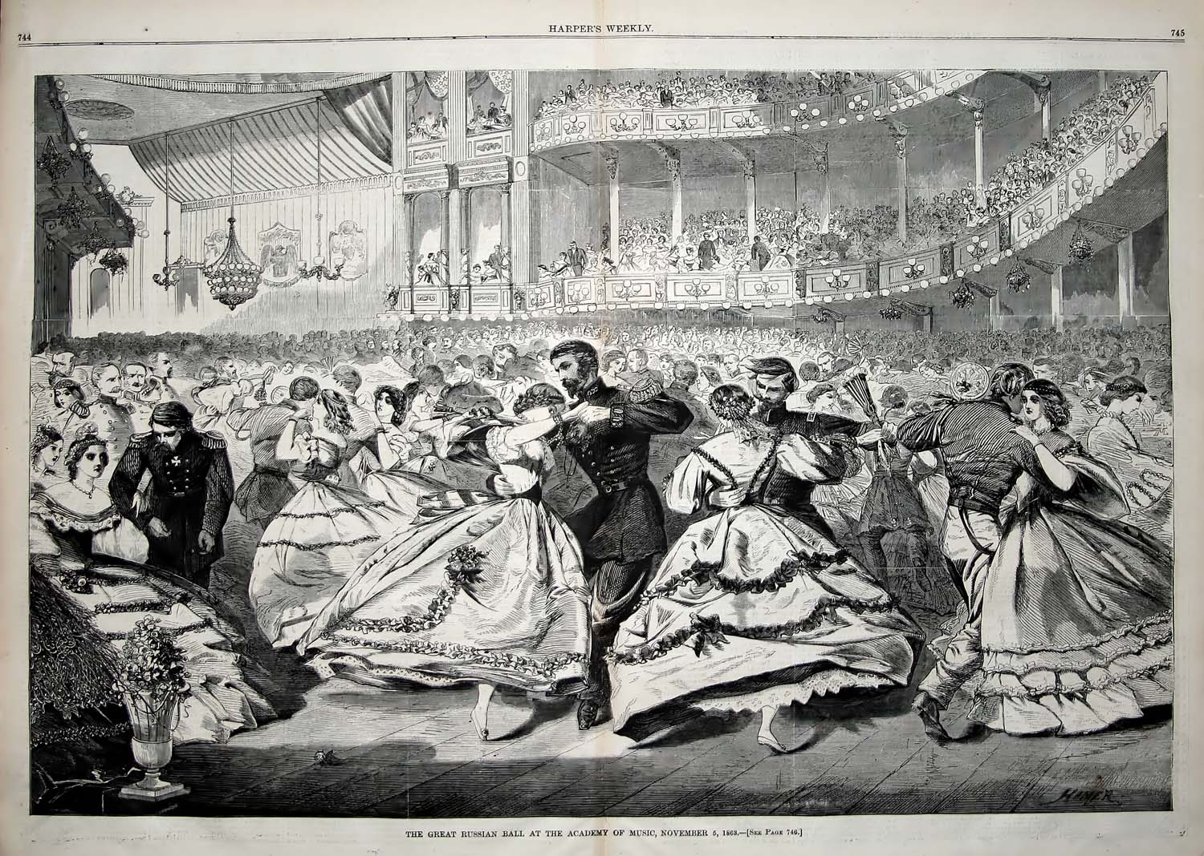

Bill Robinson