Waltz For Our Time

*­­*Violin II

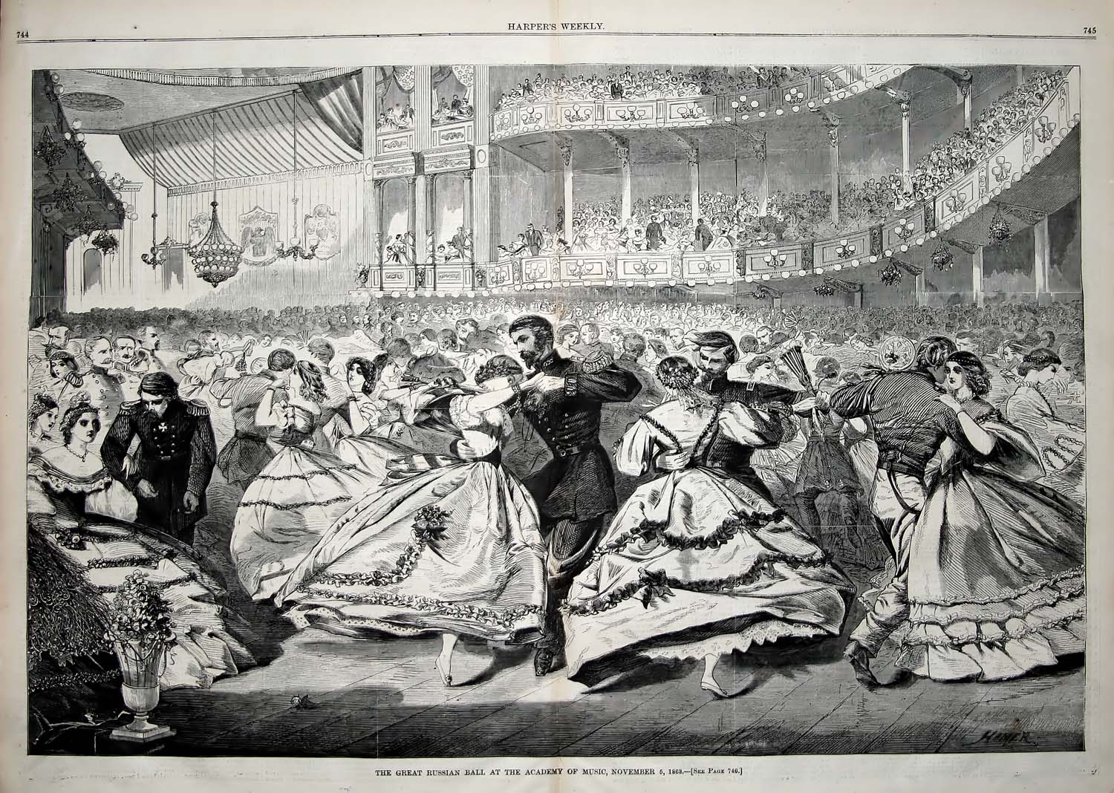

Bill Robinson