Waltz For Our Time

*­­*Viola

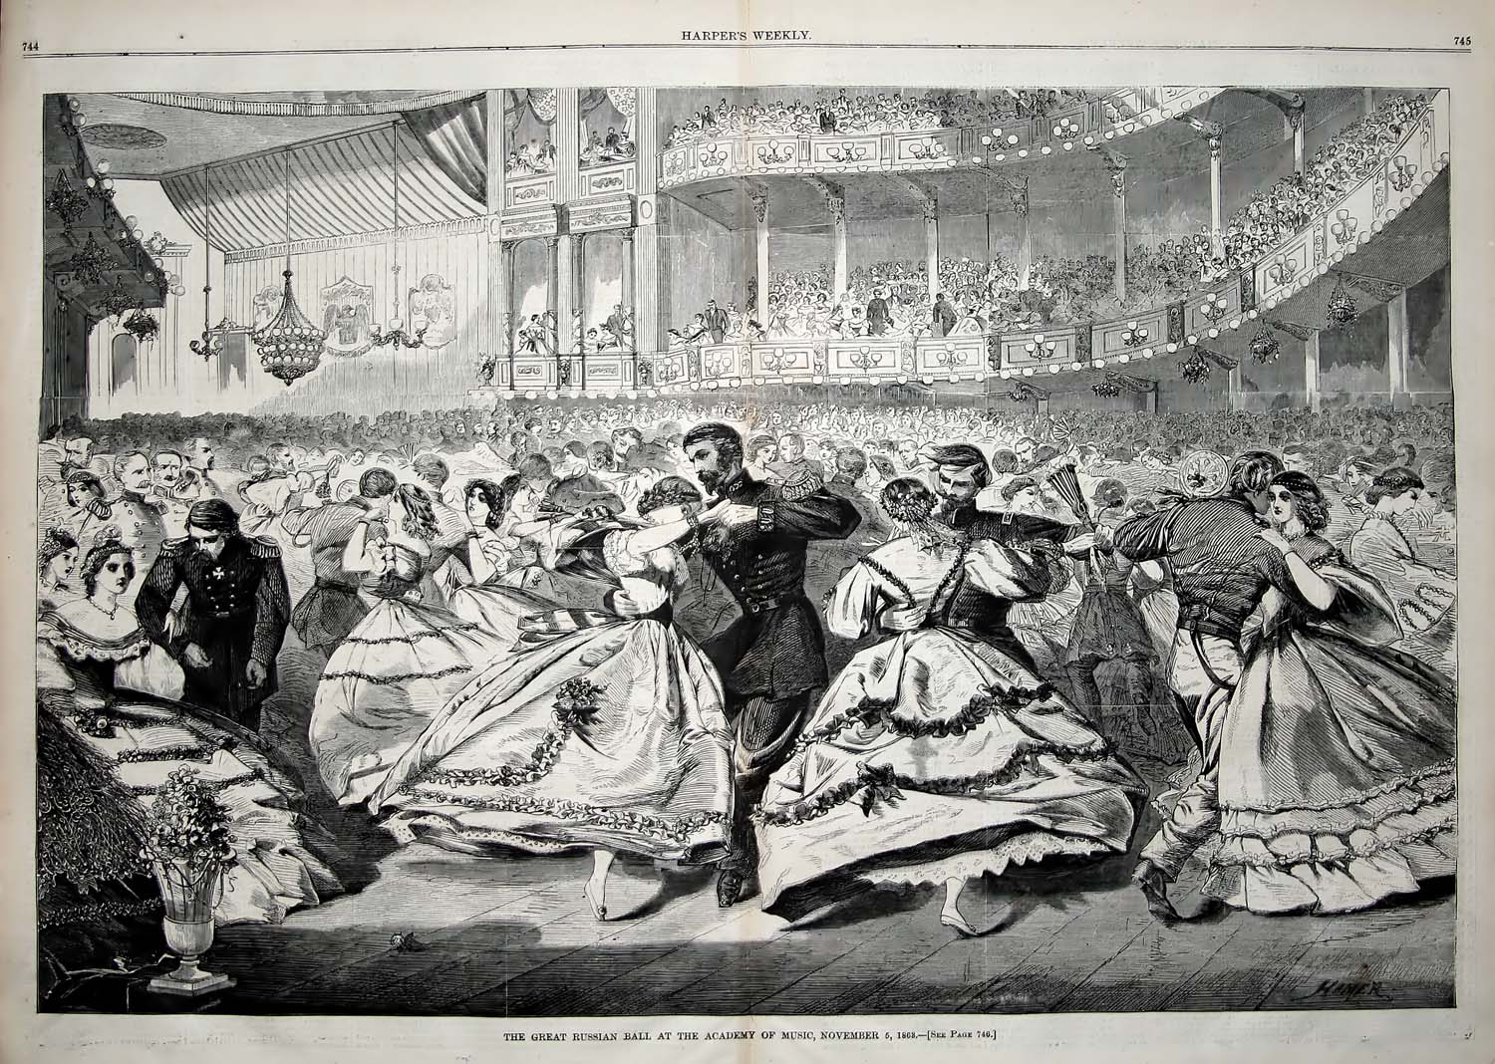

Bill Robinson