Waltz For Our Time

*­­*Double Bass

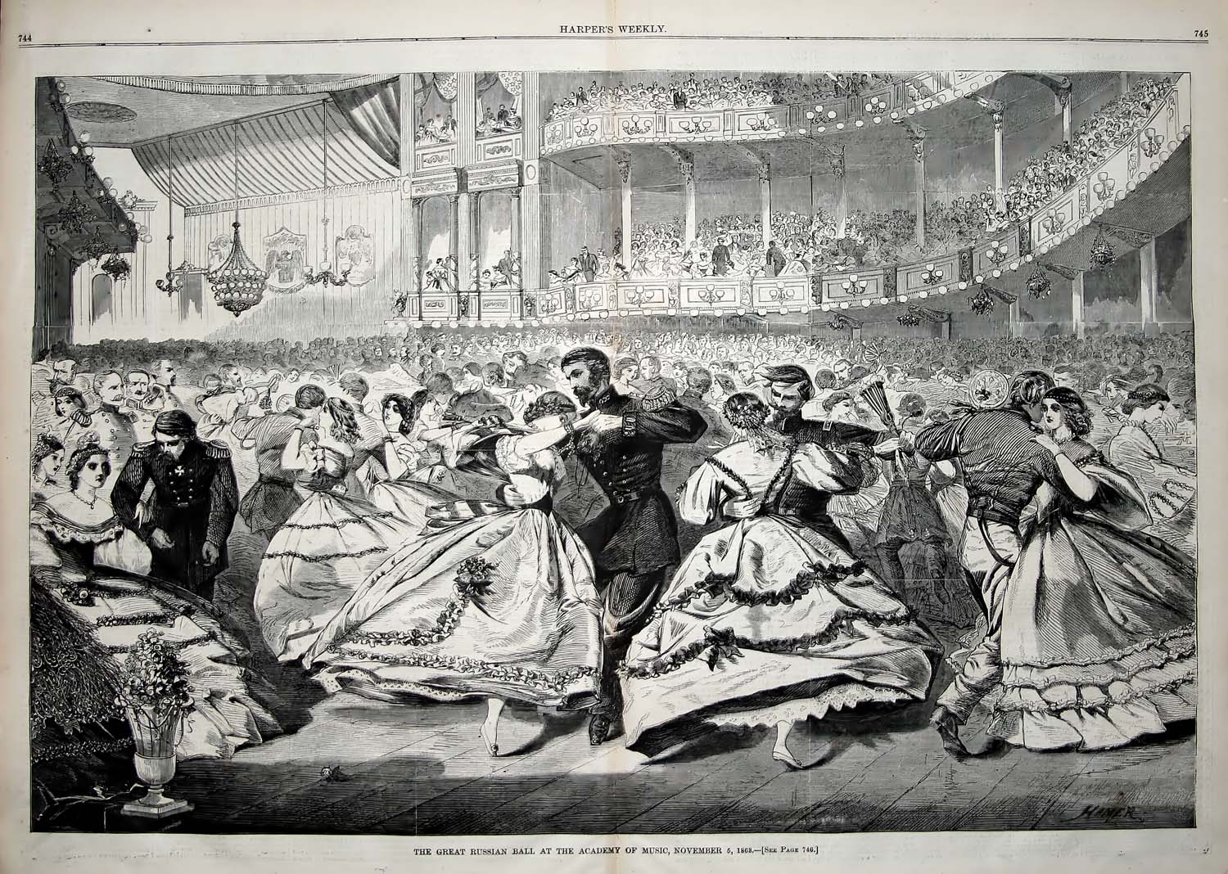

Bill Robinson