Program notes for Govinda Sonata

Robinson wrote the Govinda sonata for flutist friends Kathy Fink and Susan Fontaine, as a devotion to Krishna (for whom Govinda is another name), the supreme avatar of Hindu religions and the protagonist in the Bhagavad Gita. The sonata was written in 2006 for flute and piano, and in the same year was reset for violin for the composer’s close friend and collaborator Eric Pritchard.

The movements have the colorful, playful and often Sanskrit-inspired titles and tempo markings that are characteristic of Robinson. The first movement, titled ‘Flowers of Devotion,’ is marked Allegro bhagavata (a bilingual word-play which could mean ‘lively and worshipful’ or ‘with the joy of devotion’). Despite the allegro marking, the flavor of the movement is placid overall and devotional indeed. Robinson, typically, weaves this movement from a simple motif:
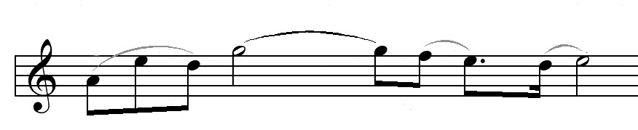

whose easily recognizable melodic and rhythmic character makes this complex, neo-Baroque movement quite accessible on the first hearing. There is a persuasive false ending followed by a short, mysterious coda that introduces the second movement without a break.

The middle movement is titled ‘Largo Govinda’ and marked Dark and Lovely. It is a meditation whose darkness would be called ‘brooding’ in any other context, but whose chromatic richness reveals the Divinity shining just as brilliantly in dark colors as in the more usual bright ones. Again, a simple motivic melody unites the entire movement, making it comprehensible despite the sometimes unfamiliar harmonies:

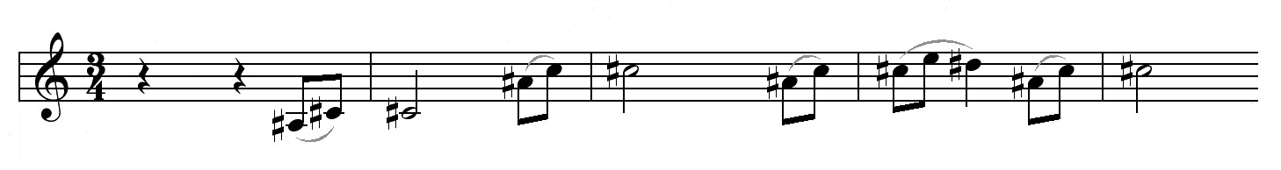

Delightfully titled ‘Power and Light,’ the finale comprises two Vivace shivaratri sections (as in the festival to Shiva, the God of Gods), bracketing a quiet, sweet middle section marked Adagio goloka (named after Krishna’s heavenly home). The surprisingly quiet concluding cadence is of the most delicious harmonic ambiguity.

Pat Marriott
WHQR-91.3fm Public Radio
Wilmington NC

© 2008 by P. W. Marriott

