Ananda Trio
for Violin, Viola, and Violoncello

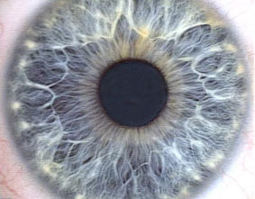
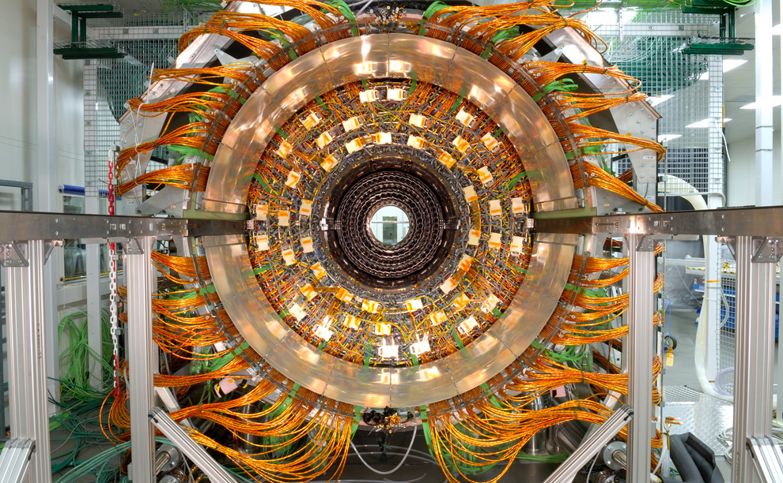
Bill Robinson

