Ananda Trio

for Violin, Viola, and Violoncello

Violoncello

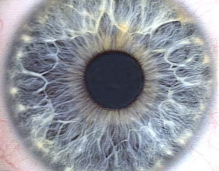

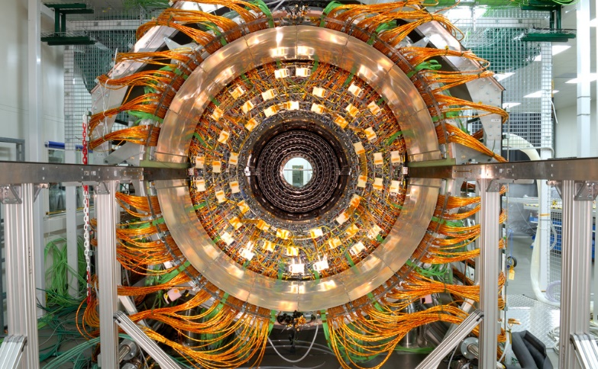

**Bill Robinson**