Ananda Trio

for Violin, Viola, and Violoncello

Viola

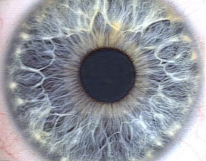

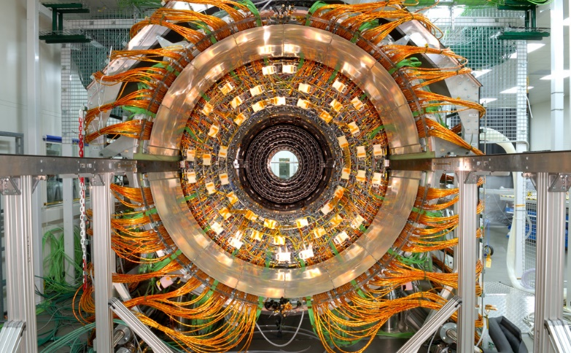

**Bill Robinson**