Ananda Trio

for Violin, Viola, and Violoncello

Violin

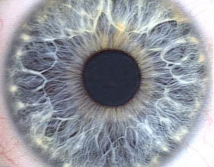

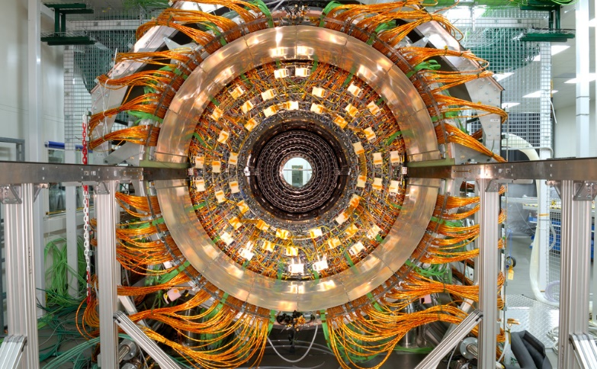

**Bill Robinson**