Concert for Clarinet and Strings

for Clarinet in A
and String Orchestra

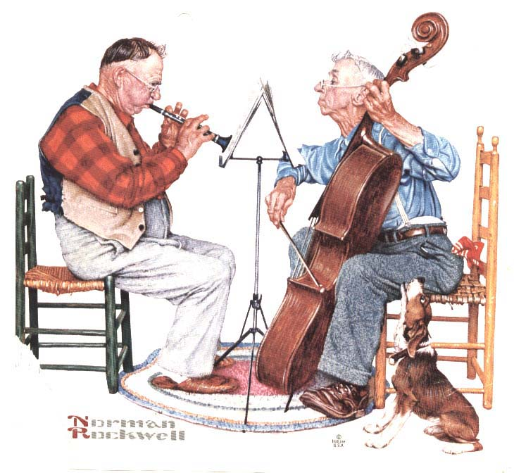
Bill Robinson

