Clarinet Sextet

for Clarinet in A, Two Violins,

Viola, and Two Cellos

(chamber version of Concert for Clarinet and Strings)

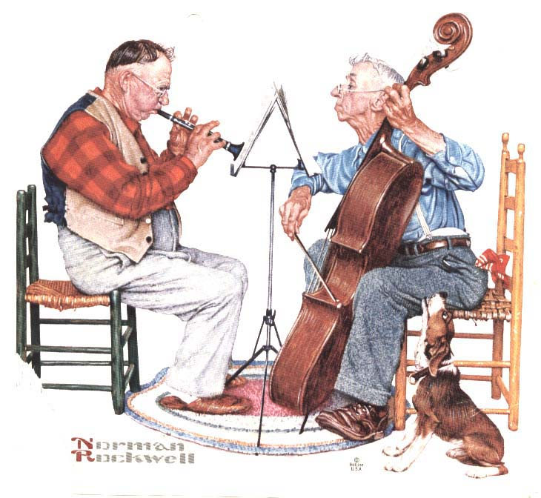

Bill Robinson