**Faith No Fear**

**for Cello Quartet**

**Cello 1**

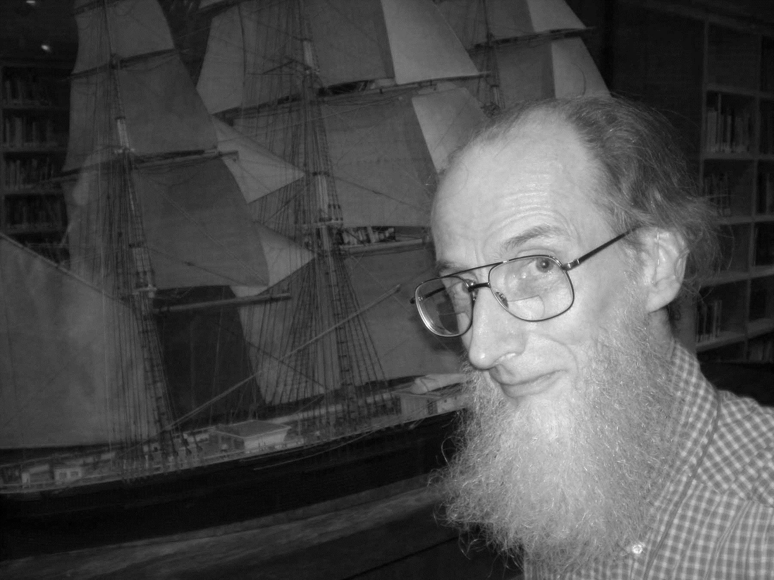

**Bill Robinson**