Nocturne
and Minuet
for String Orchestra
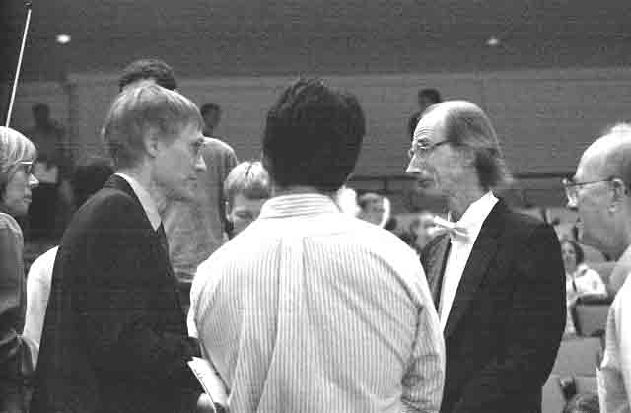
Violoncello

Bill Robinson

