Nocturne
and Minuet
for String Orchestra
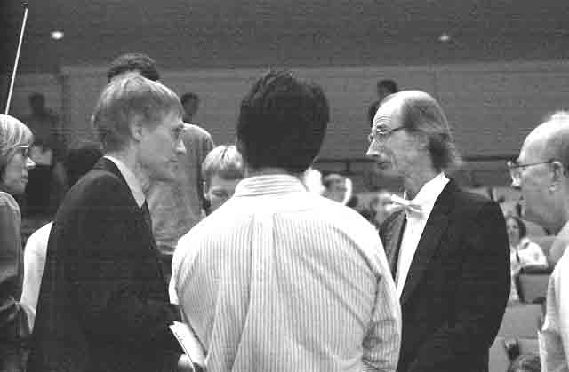
Double Bass

Bill Robinson

