Nocturne
and Minuet
for String Orchestra
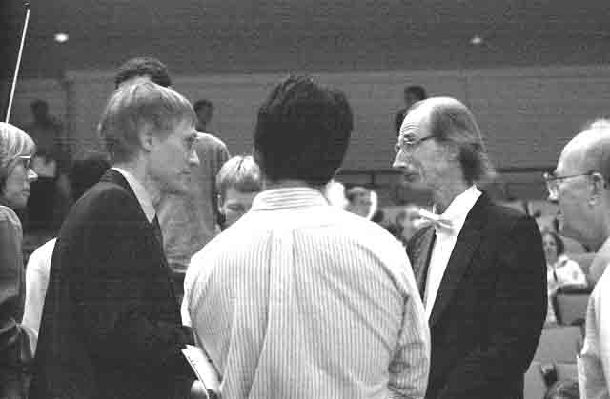
Viola

Bill Robinson

