Nocturne
and Minuet
for String Orchestra
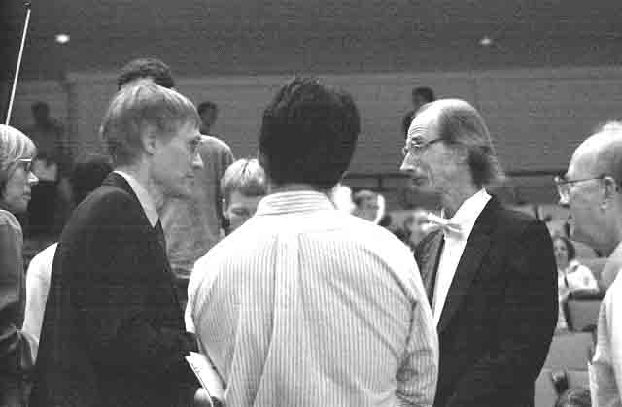
Violin I

Bill Robinson

